

DAEN 690

Project Report

Akhil Samineni

Puneetha Gumpu

Pavan Kumar Teja Mallipamu

Sai Rachana Yellareddygari

Vaishnavi Putcha

Venkata Sai Ravi Teja Adabala

Spring 2023

Computer Vision: Hydrant Object Detection

**About the Cover**

Dr. Isaac Gang is an Associate Professor at the George Mason University College of Engineering and Computing, Volgenau School of Engineering, MS Data Analytics Engineering (DAEN) program.

He joined the DAEN faculty in the Fall of 2020 from Texas A&M University-Commerce (TAMUC) where he served as an Assistant Professor of Computer Science as well as the department’s Outreach Coordinator. Before coming to TAMUC, Dr. Gang was an Assistant Professor of Computer Science and Engineering at the University of Mary Hardin-Baylor (UMHB) and an Adjunct Professor of Computer Science at the University of Southern Mississippi’s School of Computing before joining UMHB.

Dr. Gang is a former DOE grant winner, former President and Board Member of the Association of Computer Educators in Texas (ACET), Industry Advisory Board (IAB) Coordinator, and the Director of CS For All.

His current and primary teaching responsibilities at Mason largely involves Data Analytics Engineering graduate courses along with a mix of CS and AIT graduate courses. He is an affiliate faculty member of GMU’s C4I & Cyber Center.

Dr. Gang’s primary research agenda involves Big Data Analytics (emphasis on data bias and data governance), Cyber Security (ransomware, steganography, and cyberbullying), and Image/Signal Processing.

Contents

Table of Contents

Abstract 1

Section 1: Problem Definition 3

1.1 Background 3

1.2 Problem Space 7

1.3 Research 8

1.4 Solution Space 10

1.5 Project Objectives 11

1.6 Primary User Stories 12

1.7 Product Vision 13

1.7.1 Scenario #1 13

1.7.2 Scenario #2 14

Section 2: Datasets 14

2.1 Overview 14

2.2 Field Descriptions 15

2.3 Data Context 16

2.4 Data Conditioning 18

2.5 Data Quality Assessment 18

2.6 Other Data Sources 22

2.7 Storage Medium 23

2.8 Storage Security 23

2.9 Storage Costs 24

Section 3: Algorithms & Analysis / ML Model Exploration & Selection 24

3.1 Solution Approach 24

3.1.1 Systems Architecture 24

3.1.2 Systems Data Flows 25

3.1.3 Algorithms & Analysis 27

3.2 Machine Learning 31

3.2.1 Model Exploration 31

3.2.2 Model Selection 32

Section 4: Visualizations / ML Model Training, Evaluation, & Validation 34

4.1 Overview 34

4.2 Visualizations 34

4.3 Machine Learning 36

4.3.1 Model Training 36

4.3.2 Model Evaluation 38

4.3.3 Model Validation 45

Section 5: Findings 46

Section 6: Summary 47

Section 7: Future Work 47

Appendix A: Glossary 49

Appendix B: GitHub Repository 52

Overview 52

GitHub Repository Link 52

GitHub Repository Contents 52

Appendix C: Risks 53

Sprint 1 Risks 53

Sprint 2 Risks 53

Sprint 3 Risks 53

Sprint 4 Risks 54

Sprint 5 Risks 54

Appendix D: Agile Development 55

Scrum Methodology 55

Sprint 1 Analysis 55

Sprint 2 Analyis 55

Sprint 3 Analysis 56

Sprint 4 Analysis 56

Sprint 5 Analysis 56

Works Cited 57

**Figure 1.** Statistics of Fire Accidents from 1980-2021 3

**Figure 2.** Image showing damaged hydrant 5

**Figure 3.** Hydrants obscured by snow or bush 5

**Figure 4.** Hydrant Usage in Firefighting Operations 6

**Figure 5.** Model Flowchart 10

**Figure 6.** User Stories 13

**Figure 7.** VDOT Image without Hydrant 14

**Figure 8.** VDOT Image with Hydrant 15

**Figure 9**. Image Information 16

**Figure 10**. Bit depth of images 16

**Figure 11.** VDOT image with EXIF metadata 17

**Figure 12.** Sun rays blocking the view of a hydrant 17

**Figure 13.** Data Quality assessing factors 19

**Figure 14.** A picture of hydrant in Rappahannock Ln 22

**Figure 15.** A picture of hydrant in Robert Rd 23

**Figure 17**. Data Flow 25

**Figure 18**. Image Properties 27

**Figure 19**. Objects that hydrants are often confused with 28

**Figure 20**. Percentage of images with and without hydrants (in the year 2019) 28

**Figure 21**. XML parsed files into a data frame 29

**Figure 22**. Data frame grouped by hydrant 29

**Figure 23**. Original Image 30

**Figure 24**. Cropped Image 30

**Figure 25**. Cropped image into left, middle and right 31

**Figure 26**. Hydrant detected with EfficientDet model 32

**Figure 27**. Objects detected with Faster R-CNN model 33

**Figure 28**. Hydrants detected with Retina Net versions 152 (left), 101 (center), 52 (right) 33

**Figure 29**. Active Hydrants represented on a street map 34

**Figure 30**. Hydrants to be removed represented on a street map 35

**Figure 31**. Status on the number of hydrants present 35

**Figure 32**. Roboflow image statistics and train/test split information 37

**Figure 33**. Roboflow training graphs 38

**Figure 34**. Comparison of the three models (EfficientDet, Faster R-CNN, RetinaNet101) 38

**Figure 35**. Client provided Efficientdet model detecting a hydrant 39

**Figure 36**. Client provided EfficientDet Model confusing traffic cone and trash can with a fire hydrant 39

**Figure 37**. Re-trained EfficientDet model detection 40

**Figure 38**. Re-trained EfficientDet model not confusing hydrants with other objects 41

**Figure 39**. Re-trained Faster R-CNN model detection 41

**Figure 40**. Re-trained Faster R-CNN not confusing hydrants with trash cans 42

**Figure 41**. Re-trained EfficientDet model unable to detect faraway hydrants 43

**Figure 42**. Re-trained Faster R-CNN confusing hydrant with a traffic cone 44

**Figure 43**. Re-trained models unable to detect hydrants in sunlight 44

**This page intentionally left blank**

Abstract

Abstract

During a fire break out, every second counts. Statistically, there are approximately one million fire outbreaks which result in thousands of civilian’s fire fatalities and over $15.9 billion of property damage per year in the United States. In the event of a fire, firefighters rely on convenient and easily accessible fire hydrants to extinguish fires effectively. However, locating fire hydrants manually is a time-consuming and inefficient task, and may lead to delays in emergency response times. Failure to locate a fire hydrant quickly in emergency situations can result in significant loss of life and property. To address this challenge, the Fairfax County Fire and Rescue department (FCFRD) is utilizing image data collected by the Virginia Department of Transportation (VDOT) to maintain their hydrant database with more accurate and timely data. By ensuring the accuracy of the database, first responders will know where to find hydrants before they arrive on scene, improving response times. Thus, our project aims to automate hydrant detection from images with high confidence. To achieve this, our project examines various object detection methods and observed that pre-trained COCO models EfficientDet and Faster R-CNN have high performance, when implemented on our hydrant image dataset. After fine-tuning both models using 3000 manually annotated images, our Faster R-CNN and EfficientDet models produced average confidence scores of approximately 96% and 75%, respectively. Based on these results, the Faster R-CNN model was deemed the best for hydrant object detection. Our Faster R-CNN model achieved a 23% gain in average confidence scores compared to the EfficientDet model that FCFRD originally trained on 400 images. The improved hydrant detection performance will lead to a more reliable fire hydrant database.

**This page intentionally left blank**

Report

# Problem Definition

## Background

Accidental fires are a severe problem that can have terrible effects on both communities and people. According to the United States Fire Administration (USFA), there were 1,353,500 fires in the country in the year 2021, which resulted in 3,800 civilian fire fatalities and 16,400 civilian fire injuries. Fires are thought to have caused direct property damage of $15.9 billion (about $49 per person in the US) (about $49 per person in the US) (about $49 per person in the US). On an average an American fire department responds to a fire somewhere in the country every 23 seconds. A structure catches fire once every 65 seconds, and a dwelling catches fire once every 93 seconds (about 1 and a half minutes). Home fires were the cause of 75% of fire-related fatalities. This covers 11 percent of fires in apartments or other multi-family buildings and the 64 percent that occurred in one- or two-family residences. Vehicle fires were to blame for 17% of fire-related fatalities. The below image shows statistics of fire by year in United states between 1980 and 2021.

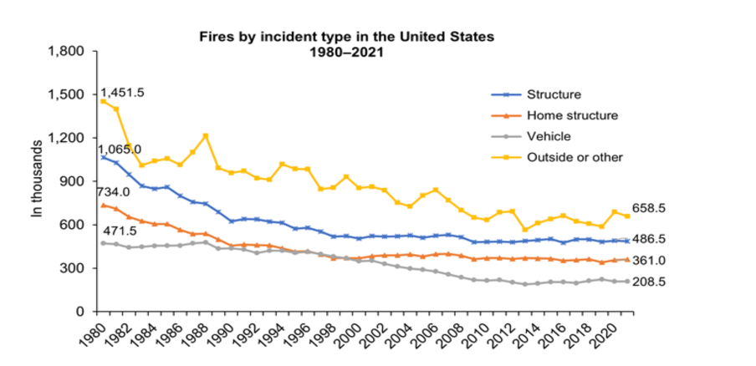

**Figure 1.** Statistics of Fire Accidents from 1980-2021

Fire and other crises are the primary issue that fire departments work to address, and their efforts to avert and respond to these occurrences are directed at safeguarding the safety of the general population. Through code enforcement, fire inspections, fire safety education and awareness initiatives, fire departments strive to prevent fire accidents from happening in the first place. Additionally, they work to promptly and effectively put out fires that have already started, as well as to treat any injured or impacted parties and offer support.

To avoid fires, fire departments use hydrants around the building for water resources but locating the right hydrant and confirming whether it is in good condition or not is a major problem that is causing delays in response. Firefighters need access to hydrants because they give them a steady supply of water, which enables them to put out fires quickly and efficiently. In order for hydrants to function, they must be connected to a municipal water supply system, such as an underground system of pipes that transports water throughout a city or town.

When firefighters arrive at a fire site, they attach hoses to the hydrant and use a water pump to supply the fire with water from the local water supply. Firefighters often use a hydrant wrench, a specialized instrument, to unlock the hydrant's valve and let water flow through the hose in order to access the water.

In a city or town, hydrants are often found in public areas and along streets. They are normally placed 500 to 1000 feet apart, though this can change based on regional legislation, the size, and the configuration of the service area.

Hydrants are typically distinguished by vivid colors, such red or yellow, and may also be identified by signs or other distinguishing marks. Before responding to a fire, firefighters can consult a map or database that typically contains the exact position of hydrants.

Many variables, like the size and severity of the fire, the layout of the area being served, and the position of the closest hydrant, can greatly affect how far a typical fire is from the hydrant. Fires frequently occur within a few hundred feet of a hydrant in urban areas with a dense network of hydrants. However, in rural locations, the distance between the closest hydrant and the fire may be several miles, necessitating the need for firefighters to bring their own water supply or use alternative sources, like ponds or rivers, to put out the fire.

In this paper we will be majorly talking about Fire hydrant detection which is a major problem as it is crucial to locate them in case of emergencies for fire and rescue team. As one of Virginia's largest and most populous counties, Fairfax County's fire and rescue service places a high focus on fire safety. In addition to assisting in a fire, they aim to avoid fire incidents. The Fairfax County Fire & Rescue Department offers emergency medical care and fire suppression in addition to a vigorous community education and risk reduction program. To help the public prepare for emergencies and fires, the department offers many classes and activities.

A city's firefighting system is not complete without fire hydrants. They offer a water supply that firefighters can use in the event of a fire, and their accessibility and position can have a significant impact on the capacity of firefighters to contain and put out a fire. Because of this, detecting fire hydrant objects has emerged as a crucial task in computer vision. Finding and identifying items in an image or video is the goal of the computer vision technology known as object detection. The objective of fire hydrant object identification is to locate fire hydrants precisely and detect their presence in real-time. There are several problems and challenges that Fairfax County Fire and Rescue may face with respect to hydrants:

Hydrant Maintenance and Location Accuracy: Maintenance of hydrants and their precise location are crucial for effective firefighting, therefore it's necessary to make sure they're both in good working order and in the right place. Issues with maintenance and accuracy can put firefighters and the public at risk while also causing delays and difficulty in firefighting operations.

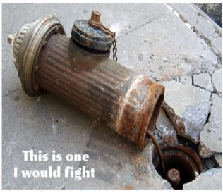

**Figure 2.** Image showing damaged hydrant

Hydrant Identification in Emergencies: Firefighters must rapidly locate hydrants in an emergency so they may quickly reach them to receive the water they need to put out the fire. Buildings, trees, and other obstructions may block hydrants, making it challenging for firefighters to locate them quickly.

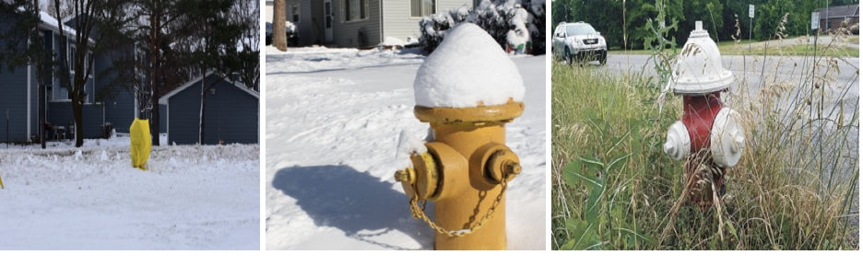

**Figure 3.** Hydrants obscured by snow or bush

Hydrant Mapping and Updating: The capacity of Fairfax County Fire and Rescue to promptly access hydrants in an emergency may be hampered by their inability to keep an accurate and current map of every hydrant in the county.

Hydrant Usage in Firefighting Operations: Firefighters must swiftly reach hydrants and attach hoses to them to obtain the water they require to put out fires. Utilizing hydrants can be difficult depending on the hydrant's age and condition, the size and kind of hose, and the water pressure.

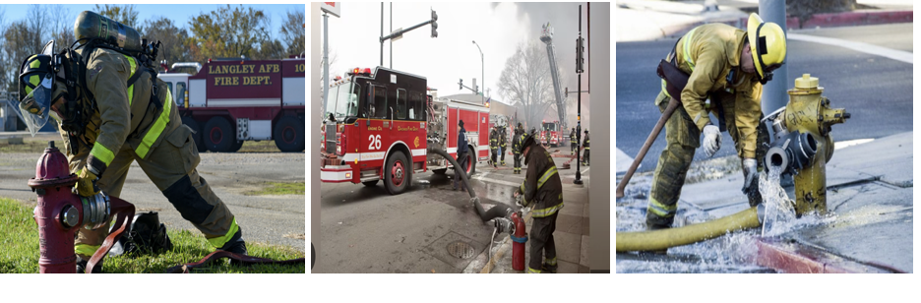

**Figure 4.** Hydrant Usage in Firefighting Operations

This task is difficult since fire hydrants can be of varied sizes, colors, and shapes, and they can also be hidden by other items like buildings, trees, or automobiles as we saw the challenges above. But because of recent developments in deep learning and computer vision, it is now possible to create systems for swiftly and accurately detecting fire hydrants in real-world circumstances.

Aside from increasing the effectiveness of firefighting operations and the safety of firefighters and bystanders, fire hydrant object identification also aids municipal planners and engineers in maintaining and modernizing the city's firefighting infrastructure.

Also, the dataset's accuracy to detect these hydrants is important for several reasons as below.

1.Firefighters depend on reliable data: In an emergency, firefighters need hydrant data to locate hydrants, so it is essential that this information is correct and current. Firefighters may waste time looking for hydrants that do not exist or may not be able to locate hydrants in time to put out a fire if the data is inaccurate.

2.Public safety: Accurate data on hydrants can assist in making sure that firefighters have access to the equipment they need to put out fires and safeguard the public. Data that is inaccurate can endanger persons and property.

3.Planning and resource distribution: Hydrant data is utilized to effectively prepare for and distribute firefighting resources. For instance, a city can decide how many fire engines and firefighters it needs to

cover a certain region in an emergency if it knows how many fire hydrants are present there. If the data for the fire hydrants is incorrect, the city could not have the appropriate resources available when they are required.

4.Hydrant data is utilized to keep track of maintenance and repair requirements. Inaccurate data could prevent damaged hydrants from being found and fixed, endangering everyone's safety.

Inadequate planning and resource allocation can result from inaccurate hydrant data, which can also cause longer firefighter response times and an increased risk to the public's safety. Hydrant detection databases must be accurate and current to give firefighters the tools they need to conduct their jobs well and keep the public safe. So, it is important to see that the dataset we use is accurate for our project.

The following are the roles that will be taken to support hydrant object detection project:

Data gathering and preparation: To gather and sanitize data about hydrants, including their locations, pictures, and other pertinent information, data scientists collaborate with the fire service.

Reporting and Visualization: Produce visualizations to assist the fire department in comprehending the findings of the hydrant detection project and to share those findings with stakeholders. Additionally, they could offer written reports on the project's development and outcomes.

Model Development: Create machine learning models to precisely locate and classify fire hydrants in photos using computer vision techniques. The right methods may need to be chosen, the models may need to be trained, and the parameters may need to be adjusted.

Deployment: Helping to implement the hydrant recognition models in a real-world setting, like on fire vehicles or in a mobile app. To make sure the models are operating at their best.

We are sure that this project not only helps the fire department, but it helps lot of others like a city planner, Hydrant maintenance crew, property owner, traffic officer etc. To conclude things successful completion of this project helps the community to plan the fire fights and in controlling the fire as quickly as possible helping as a support system for the fire department.

## Problem Space

For this project, the Fire and Rescue Department is trying to minimize the issues and work efficiently by looking into different possibilities to approach the issue when a fire accident is caused. The main concern they want to address is to locate hydrants efficiently. Due to uncertain circumstances, the fire hydrants may not have proper functionality or be destroyed, so the Fire and Rescue Department of Fairfax County created a model for hydrant detection where certain issues need to be addressed.

For this project, the input data is the images provided by the clients for object detection. The output results to be expected are successfully identifying fire hydrants with high accuracy. The hydrants need to be detected while ignoring the other objects like mailboxes, traffic lights, humans etc. Finding fire hydrants in less time is essential. If we have the proper information about hydrants before any fire accidents occur, we can minimize the time and actively put the hydrants in better use.

By working with data scientists on the hydrant object detection project, Fairfax County Fire and Rescue can address these challenges and improve the preparedness for fighting fires. By using machine learning and computer vision techniques, data scientists can help the fire department accurately locate and identify hydrants in emergency situations, maintain up-to-date maps of all the hydrants, and optimize their usage in firefighting operations. The Fire and Rescue Department is trying to resolve the issues mentioned above by using object detection and machine learning algorithms.

The main problem we are focusing on is to detect fire hydrants that are placed in Fairfax County. We need to know the hydrants count and where hydrants are located to make the job easier. Knowledge of fire hydrants present in the location of accidents can save time to take the next step to save lives.

## Research

There have been numerous studies that have tackled the crucial task of object detection in computer vision using noteworthy models like Mask R-CNN, YOLO, EfficientDet, etc. that are listed below:

A deep learning algorithm called Mask R-CNN performs object detection using instance segmentation and object recognition in images. TensorFlow and Keras libraries are used for implementation. This is a deep Convolution Neural Network model that returns both bounding box and mask for a detecting object. [1] is one of the tutorials that covers the overview of the Mask_RCNN project for object detection with TensorFlow 1.14 by preparing the model configuration parameters, building the model architecture, loading the model weights, reading an input image, detecting objects, and visualizing the results. A detection model is built using the MaskRCNN class in mrcnn.model, there are several parameters that must be specified to control non-maximum suppression (NMS), image size, intersection over union (IoU), number of ROIs per image and many others. An alternative way to use this model is by copying mrcnn folder to the project used directory. Mask R-CNN can be used in successful detection of hydrants but usually R-CNN has a slow computation speed. To overcome this, Faster R-CNN can be used as it is a region-based convolutional neural network that uses a Region Proposal Network (RPN) to generate ROIs.

Disaster Preparedness helps municipal agencies to identify appropriate locations to prevent potential accidents before extreme weather conditions. [2] is a study of disaster preparedness using participatory sensing to localize distinct vulnerable objects. This study mainly addresses the issue of localizing a distinct object by proposing a novel geospatial localization method to identify distinct objects using participatory sensing. By illustrating how distant objects in metropolitan areas can be robustly localized from repeated observations through the innovative localization procedure, this study contributes to a methodological element and understanding of geospatial localization in participatory sensing. This process consists of deep learning- based object detection, magnetic declination adjustment, and formulating line-of-sight equations. This proposed approach requires a massive collection of data which would thereby facilitate disaster preparedness by locating distinct objects at risk. The proposed method can be integrated with already-available programs like Google Street View or Google Map, and these programs would be a suitable way to see the localization results obtained by the proposed method. This study's key discovery is that, even with a large amount of noisy data, the accuracy of geographic localization may be improved by including repeated observations from non- experts. This conclusion has significant ramifications for our comprehension of how crowdsourced data should be used to comprehend local information in large urban regions. The location of local vulnerabilities to extreme weather events can be used by practitioners to better understand where to focus their attention in order to lessen the potential harm caused by severe weather in urban environments. One of the drawbacks is in the preprocessing stage. However, there is a chance that the data cluster chosen during the preprocessing stage will contain some noisy data. Creating a powerful filtering module to eliminate noisy data that lacks the precision of measured values like compass bearings or geographic coordinates could be one strategy to address this problem. This paper's focus is on the geographic localization of distant (static) items in the lead-up to extreme weather events in the context of disaster preparedness, not on damaged areas or moving objects during the events. This paper shows us a way to overcome challenges that our project might face like snow-capped hydrants, hydrants covered in the shade of tress while testing the detection model.

[3] is a website post created by Adrian Rosebrock who used OpenCV for YOLO (You Only Look Once) object detection. This tutorial clearly explains how to take advantage of OpenCV’s DNN function to load YOLO from disk and the three primary object detectors – R-CNN (Region based Convolutional Neural Networks), Fast R-CNN, Faster R-CNN; Single Shot Detector (SSDR-CNNs (Region based Convolutional Neural Networks Shot Detector) R-CNNs (Region based Convolutional Neural Networks) O. Even though R-CNNs (Region based Convolutional Neural Networks) have great accuracy, the drawback with R-CNN is its slow computation speed and not being an end-to-end object detector. This is because R-CNNs use a two-stage strategy, whereas SSDs and YOLO use a one-stage strategy for detection. Among these, YOLO is a great model of a single-stage detector. Yet, there is an arguable limitation of YOLO object detection, i.e., small objects are not well handled, especially when they are closely grouped together. This is because the YOLO algorithm divides the input image into a SxS grid, due to that each cell in the grid predicts only a single object, if there are multiple small objects in the same cell, YOLO will not be able to detect them, which will lead to missed object detections. YOLO works well for detecting large objects. So, if the dataset contains small, grouped objects, Faster R-CNN works well; however, it has the slowest computation speed. SSDs are good with speed and accuracy, but they struggle with small objects like YOLO.

[4] mainly talks about image pyramid methods in image processing. Image pyramid mainly consists of a set of lowpass or bandpass copies of an image. Every copy represents the information in different scales of the image. This paper talks about the two methods of image pyramid which are Gaussian and Laplacian pyramids. According to the paper gaussian pyramid mainly focuses on to reduce the resolution of an image while Laplacian pyramid mainly focuses on scaled-image analysis. This paper also contains the working steps of an image pyramid with some examples. These methods can be used to play around with the resolution of the images to transform and prepare the images for model building.

[5] talks about the foundation of deep learning techniques used in object detection. It gives information about object localization and object detection. Object localization refers to the detection of a single beneficial object in the image, whereas object detection refers to detecting more than one object. It talks about the sliding window algorithm, which can find objects with the help of the sliding window feature. This site mentions anchor boxes where we can detect multiple objects with coordinates given whereas sliding windows can only detect one beneficial object. This paper gave us a clear answer to why not use sliding window method for object detection.

It is difficult to maintain high accuracy while using resources efficiently, both in terms of computation and memory. [6] presents scalable and efficient object detection model with EfficientDet family on the COCO dataset. EfficientDet-D7 employs the innovative BiFPN (Bidirectional Feature Pyramid Network) module to facilitate effective multi-scale feature fusion, as well as a compound scaling technique to balance model depth, width, and resolution. Testing demonstrates that EfficientDet-D7 outperforms current state-of-the-art detectors in terms of accuracy and efficiency by running 8 frames per second on a single GPU, making it a potential strategy for practical applications. However, it is possible that its performance on a specific class of objects may not be accurate as other specialized models. This inconsistency is because, usually object detection models are trained on large datasets that contain diverse range of object classes and that’s how the model learns to detect a wide range of objects, making it more challenging to detect specific objects with high accuracy. To address this issue, researchers frequently use certain datasets or object classes to fine-tune object detection models. For instance, researchers can fine-tune the model using a dataset that has a lot of samples of that object class if the objective is to recognize a specific sort of object, like pedestrians or cars. The model's accuracy for that particular class may be enhanced as a result. In our case, we can improve the accuracy of the existing EfficientDet model by fine-tuning the model with images containing hydrants (annotated images).

[7] addresses the common issue of class imbalance in object detection, where the number of samples not containing objects outweigh the number of object samples, by introducing a novel focal loss function. This results in a bias towards a particular class of objects and decreases accuracy of rare objects. Retina  
Net solves this problem by introducing a focal loss function that down-weights the contribution of easy examples and focuses on hard examples. The foundation of Retina Net's design is a feature pyramid network (FPN), which creates a number of feature maps at various scales. Each feature map is then defined with a collection of anchor boxes that act as a point of reference for object detection. A group of classification and regression sub-networks are linked to each anchor box, and these sub-networks forecast the object class and bounding box offsets for each anchor box. The usage of both high accuracy and fast inference time of Retina Net is highly effective for object detection systems. We explored Retina Net model because we faced class imbalance issue, with 15% images including hydrants and rest of the images not including hydrants.

## Solution Space

According to the Fire and Rescue Department, there is a problem with confirming the location of every hydrant. For this reason, we are being asked to build a machine learning which can give an output of the location of the hydrants and identify the hydrants which are missing or damaged. We have to detect such types of hydrants and notify the person responsible so they can fix it before any emergencies.

As the process of manually locating hydrants in thousands of images is very hard to do we want to build a model to do the work. For this we want to build a Mask R-CNN model and train it using the images given by VDOT to identify and locate hydrants.

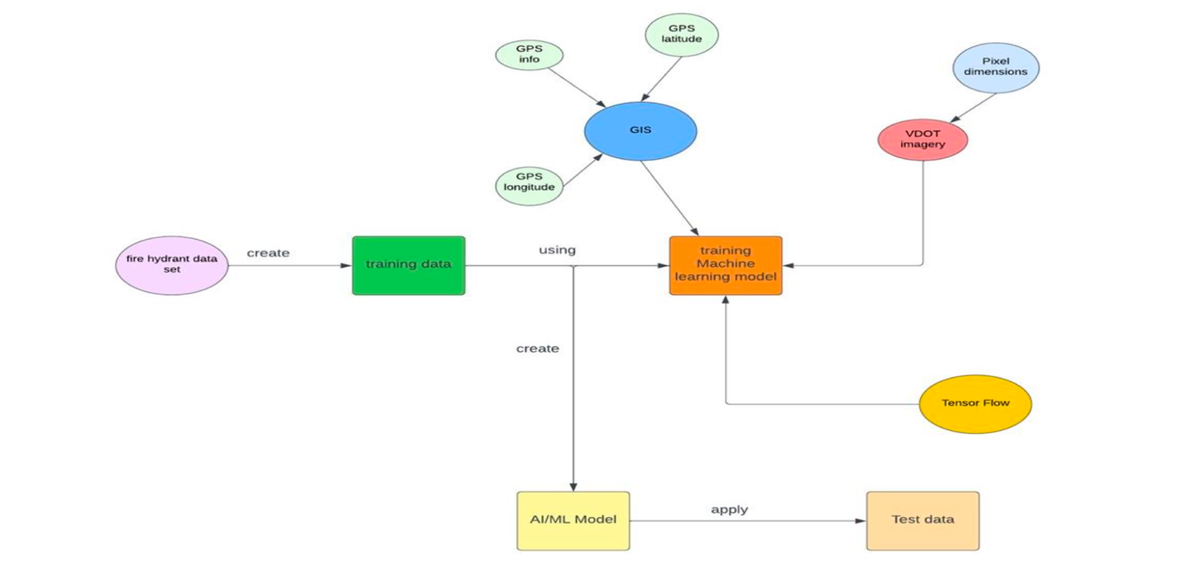

**Figure 5.** Model Flowchart

At the end of this project, we will have a model which can be used to locate and identify hydrants which can be used by fire fighters during emergencies. We want to also try using pictures from google street view to see how the model is working so it can be used for images from multiple sources.

The fire hydrant detection system that we develop will be useful to a number of organizations, including fire departments, city planners, and communities by making it possible to identify fire hydrants quickly and precisely in an emergency. This solution will speed up firefighting efforts, improve response times, and boost public safety. For the target group to embrace and use the solution broadly, we will make it simple to use and accessible.

The system we create will be capable of real-time image processing and be able to deliver quick and precise hydrant detection results. The system will be scalable and able to handle large amounts of data, including high-resolution images.

There are some problems which may occur during our project. We have found some solutions which may help us when they occur.

With the help of Custom object detection using TensorFlow we can adjust the object detector so that it only displays the objects that are tremendously important to you to limit the clutter in the prediction result. Haar classifier can be used to divide the image into several rectangles, which are then used to create a cascade of straightforward classifiers.

Our first problem that we predicted is image resolution. Image resolution may differ from image to image when we have our data. As our dataset contains many images which are taken from various angles, we may have hydrants anywhere and, in any size, when we see the image. When we were doing our research, we came across the Image Pyramid technique. This technique mainly focuses on finding objects in images at different scales which helps us in detecting hydrants without worrying about the object dimensions.

We have predicted another problem with the surroundings of hydrants. We may miss some hydrants which are far away or are covered with any object in the image like snow, bush etc. We have come across a technique called Sliding Window which generally slides across the image with a window which goes to every corner of the image and detect the object we want. We also think it may help us with not detecting the objects which are not hydrants as it slides to every corner of the image while trying to detect the hydrant.

We think the above problems can be solved during the project. There are also some problems we did not find adequate solution to like not detecting the hydrants which are in the same image of another hydrant but are not clear because of the distance between the hydrants. This is a problem because if the model detects the far hydrant and has the image of the hydrant separately in a clear angle the data will get duplicated. We also have a problem with the angle of the image taken because there may be images of the same hydrant in different angles. We also came to an understanding that although our model detects hydrants accurately to help fire department during emergencies it may not be able to detect the functionality of a particular hydrant which may lead to lot of damage during emergencies.

## Project Objectives

In Fairfax County, there are close to 70000 fire hydrants. We want to develop an AI model that can locate and identify these hydrants so that, in the event that any are removed, damaged, or sheared off, we will detect them and update the hydrants database with accurate data. For this purpose, we intend to use tools like TensorFlow.

Given the difficulty of manually confirming each of the tens of thousands of fire hydrant locations in Fairfax County, we wanted to create this model that will also help firefighters respond to emergencies promptly. With the use of images provided by Fairfax Fire and Rescue department, we want to build a functioning prototype by using a tensor flow model. The flowchart for the model to find fire hydrants can be seen in the **Figure 5**.

At the end of this project, we will have a functional fire hydrant detection system that can correctly identify and locate fire hydrants in images. We will have learnt more about the difficulties, best practices, and restrictions associated with object detection and computer vision, as well as any requirements for system enhancements.

We will have a better knowledge of the challenge of identifying fire hydrants in photographs, including the challenges and constraints posed by this work. At the end of this project, we also studied the best methods for creating object detection systems, such as choosing the right techniques and algorithms, building models using the right data, and assessing the effectiveness of such models.

We will have developed a method for quickly identifying and locating fire hydrants in emergency situations by precisely detecting them in images. We will have the solution to execute quickly, be resilient against a variety of environmental factors and item appearances and have a high accuracy rate. Additionally, we will make the interface for accessing the system as user-friendly as possible.

## Primary User Stories

User Stories:

* As a firefighter, I want to be able to quickly locate fire hydrants in an emergency so that I can easily access water to extinguish the fire.
* As a fire hydrant maintenance worker in the local fire department or water utility company, I want to know the location of all hydrants in the city so that I can plan maintenance and upgrades as needed to ensure that they are always in good working condition.
* As a property owner, I want to be able to check the location of hydrants near my property so that I can ensure that there is adequate access to water in case of a fire.
* As a hydrant inspector, I want to be able to quickly locate hydrants for inspection so that I can efficiently perform my job and ensure that all hydrants are functioning properly.
* As a first responder, I want to be able to quickly locate hydrants in the event of an emergency so that I can quickly access water to provide aid.
* As a city resident, I want to be able to see the location of hydrants in my neighborhood so that I can be better prepared in case of an emergency.
* As a local utility company, I want to be able to access information about the location of hydrants so that I can plan new service installations and maintenance work in the area.
* As a developer, I want to be able to integrate the hydrant detection system into my new building designs so that I can ensure that my buildings have easy access to fire suppression resources.
* As a traffic officer, I want to locate fire hydrants so that no vehicle is parked within 15 feet from fire hydrant.
* As a user, I'd like to find fire hydrants so that I can obtain a valid permit from the fire department to use water from public fire hydrants.
* As a member of a repair crew, I'd like to keep track of hydrant locations in order to perform annual quality inspections. As a contractor, I want to find damaged fire hydrants so that I can negotiate contracts for the cost of materials to repair and replace hydrants, as well as collaborate with other municipalities to get the best deal on purchasing new fire hydrants.
* As a water quality officer, I want to locate and inspect fire hydrants to ensure that no fire hydrant is connected to contaminated water that contains bacteria strains that can cause severe health problems, as well as to ensure that there is no water leakage.

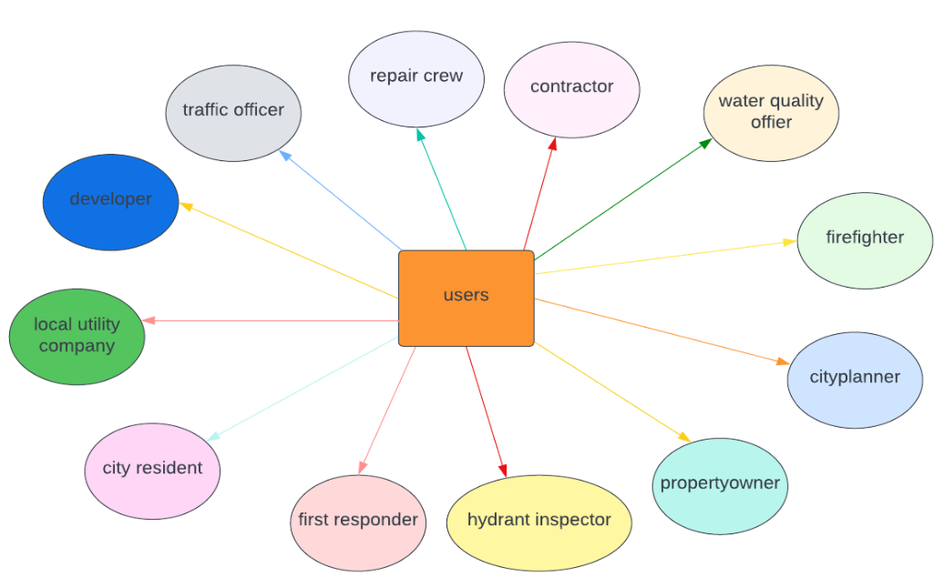

**Figure 6.** User Stories

## Product Vision

The final product will be a software program that can detect and identify fire hydrants in each area. Fire departments, municipal governments, and private entities in charge of emergency response and fire protection can use this product. In the event of an emergency, these organizations will use the device to find fire hydrants, cutting down swiftly and precisely on response times and enhancing safety. To find and locate fire hydrants, the product uses Google photos, cameras, and/or other technologies.

### Scenario #1

Firefighters are the ones that arrive on the scene first after any fire accident. They will arrive at the scene and search for a hydrant to attach their tanks to. However, if they are unable to locate the fire hydrant at the anticipated location, they will need to alter their entire strategy and locate a different hydrant nearby. They would have to spend extra time to find another nearby hydrant. A home structure fire occurs for every 93 seconds in United States based on a report [8]. So, responding to a fire accident on time is very crucial as even an extra Second which would result in more casualties and property damage. With the use of our fire hydrant detection system, we will be able to prevent these occurrences since firemen will now be able to confirm the location of hydrants in advance and take appropriate action. So, both lives and property harm can be prevented by our fire hydrant system.

### Scenario #2

Fire hydrant detection systems can be used by city planners and engineers to locate and determine the condition of fire hydrants in a specific area. This information can be used to create more efficient and effective fire response plans.

# Datasets

## Overview

To solve the problem space, we need to have a better understanding of the dataset given. Our dataset is provided by the VDOT (Virginia Department of Transportation). The VDOT images we acquired are images of streets in Fairfax County which may or may not contain hydrants. The images provided for us are from 2018 to 2020. VDOT collects these images annually. These images contain EXIF (Exchangeable Image File) metadata. The images given are not labelled to indicate whether they contain hydrants, nor are any images annotated with bounding boxes to show locations of hydrants. This image dataset has a total size of 288.3 GB. We can use these images for hydrant detection.

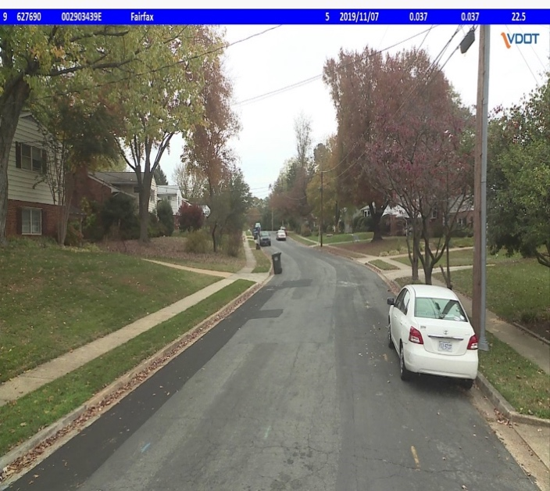

**Figure 7.** VDOT Image without Hydrant

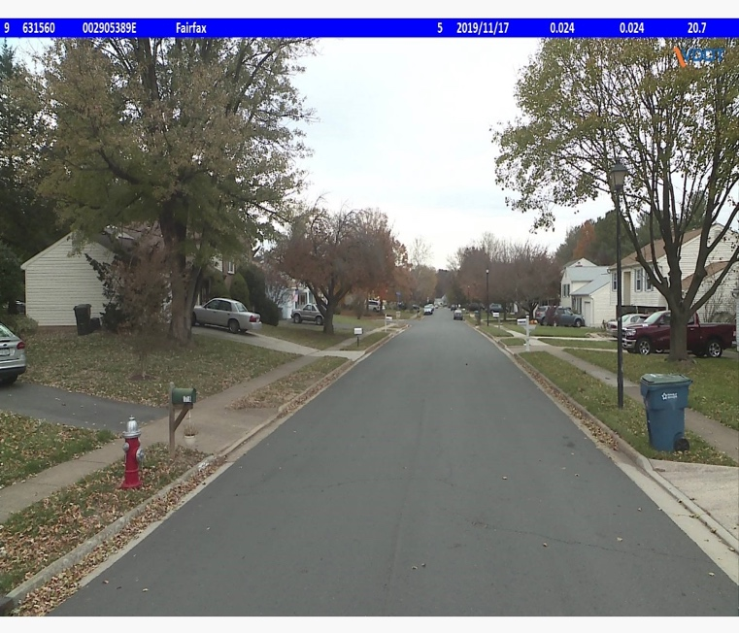

**Figure 8.** VDOT Image with Hydrant

## Field Descriptions

The given dataset contains images and each image in the dataset have EXIF metadata. Exchangeable image file format (officially known as Exif, as per the JEIDA/JEITA/CIPA specifications) is a standard that outlines the formats for images, sound, and auxiliary tags used by digital cameras (including smartphones), scanners, and other systems handling image and sound files recorded by digital cameras. The following existing encoding formats are used in the specification along with specific metadata tags for image and audio files: RIFF WAV for audio files (linear PCM or ITU-T G.711 -law PCM for uncompressed audio data and IMA-ADPCM for compressed audio data), TIFF Rev. 6.0 (RGB or YCbCr) for image files, and JPEG lossy coding for compressed image files. JPEG 2000 and GIF-encoded images are not supported. This specification includes the Exif audio file specification as well as the Exif image file specification. Images in the dataset include metadata of location coordinates (latitude and longitude), the date of the image clicked, and the location name. There are 720,000 unprocessed images of 288.3 GB size and all the images are in JPEG format with a bit depth of 8bits as seen in **Figure 10**, and each image occupies an average of 350 KB on disk with a dimension of 1920 by 1080 as seen in **Figure 9**.

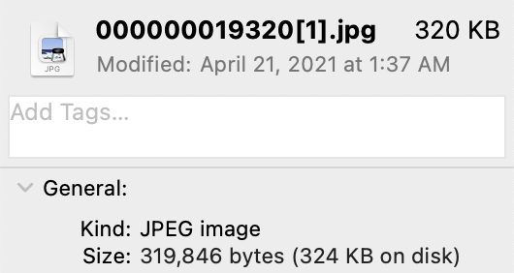

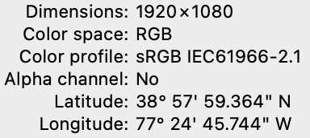

**Figure 9**. Image Information

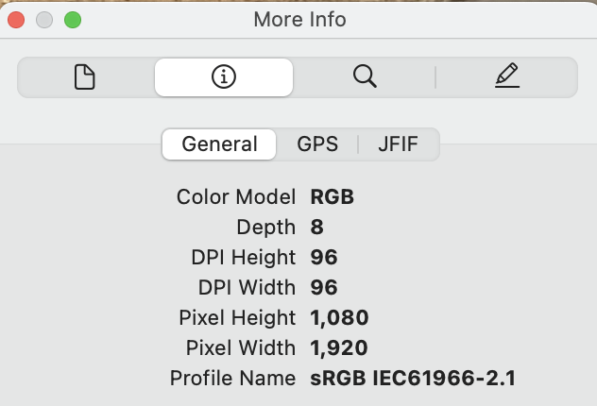

**Figure 10**. Bit depth of images

## Data Context

Our dataset contains VDOT images with EXIF metadata collected in the years 2018, 2019 and 2020. The governmental agency in charge of managing Virginia's transportation system is called the Virginia Department of Transportation (VDOT). The Virginia Department of Highways Building, located in the heart of Richmond, serves as the organization's headquarters. Roads, bridges, and tunnels throughout the commonwealth are constructed, maintained, and run by VDOT. The images in the dataset are collected by mounting a camera to a VDOT vehicle which goes around various streets to collect imagery. VDOT takes pictures to keep an eye on the state of Virginia's infrastructure, including its roads and bridges. They are also used to record the performance of its maintenance operations, road development projects, and traffic conditions. The photographs are examined to learn more about traffic patterns, spot potential safety concerns, and keep track of how building projects are coming along. These photos aid VDOT in maintaining the effectiveness and safety of Virginia's bridges and highways. These images (as seen in **Figure 10**) Can be used to train the deep learning neural network model to detect hydrants accurately. These images are street view images taken by VDOT but not images that only contain hydrants.

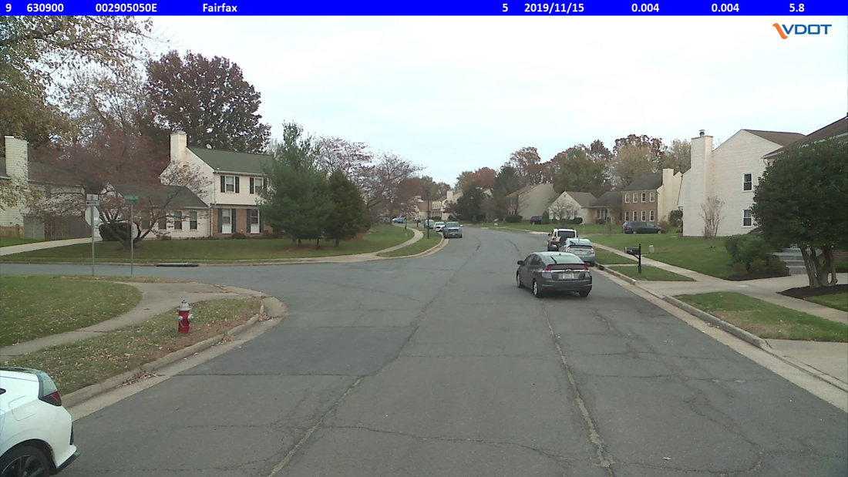

**Figure 11.** VDOT image with EXIF metadata

There is no certainty that all the images in the dataset contain hydrants, there are images with and without hydrants, people, animals, etc. Additionally, the dataset also contains images with sun rays/ shade blocking the view even for a human eye to detect objects as seen in **Figure 11**, blurry images, and bushes/tree shadows covering hydrants.

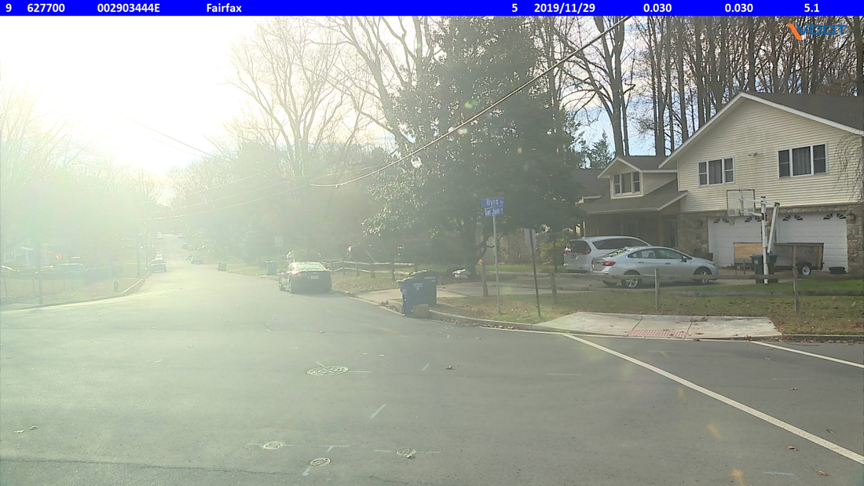

**Figure 12.** Sun rays blocking the view of a hydrant

Talking about bias in data, Images or videos of fire hydrants may contain biased information due to factors including how they were gathered, the demographics of the individuals who did so, or how the information was labeled or annotated. For instance, if the images are tagged wrongly then it is difficult to tell if the image contains hydrant or not delaying the analysis.

Ground-based cameras, drones, and satellite photography are just a few of the several camera kinds and setups that are frequently used to record the data. In addition to possible blockage, reflections, and other challenging elements that can make hydrant detection challenging, the photographs might have been taken in a variety of weather and lighting situations.

## Data Conditioning

Data conditioning, sometimes referred to as data preprocessing, is the process of transforming raw data into a format that can be easily analyzed by a machine learning algorithm or other analytical tools. Data collection, data balancing, data cleaning, data labeling, removal of duplicates, removal of outliers, etc. are some common data conditioning stages. For our dataset, we need to perform the below steps.

**Labeling:** The initial step we have done to evaluate the model's accuracy was to label images for training dataset**.** We have labelled the images using CVAT (Computer Vision Annotation Tool) developed by Intel. The current model we have primarily confuses with traffic cones, which are similar to hydrants, yet consistently identifies them as hydrants. To prevent this misdetection, we also annotated the images with traffic cones to prevent the model from being confused.

Human annotators draw bounding boxes around each fire hydrant in the scene to identify its location in the picture. This process labels the data. Other details regarding the hydrant, like its color or kind, could also be included in the annotations.

The aim of hydrant object detection is to precisely locate hydrants in new photos. This information can then be used for a variety of purposes, including urban planning, emergency response, and maintenance of public infrastructure. To accomplish this, machine learning algorithms can be trained on annotated data, enabling them to discover patterns and traits that are distinctive of hydrants and then make use of this information to recognize hydrants in fresh photographs.

**Resize and Crop images:** Images in a dataset may have different sizes and aspect ratios. To ensure that the images are of the same size, you can resize or crop them. Resizing involves changing the dimensions of the image, while cropping involves cutting out a portion of the image. Because we are looking for fire hydrants, which are often found on the ground, we removed the top 33% of the image. Also, while the images in our dataset have pixel size of 1920 x 1080, our models need data with a 640 x 640-pixel resolution. We achieved this by splitting the remaining portion into three parts and then resized them into 640 X 640-pixel dimensions, which is the required dimensions for our models.

## Data Quality Assessment

We have images in our data set; the images in this data set are from 2018 to 2020.

We can see from the image dataset that the numbers in the images indicate the following.

1. Image number

2. Geographical coordinates

3. Location-Fairfax

4. Year/Month/Date

5. Image resolution: The value might represent the spatial resolution of the image in meters per pixel.

6. Image scale: image scale refers to the relationship between the size of an object on the ground and its representation on an image.

Data quality (DQ) is defined as the data's suitability for the purpose specified by the user. It is subjective because the concept of quality is defined by the expectations of end users.

Data quality can be measured in multiple dimensions with equal or varying weights, and the six key dimensions listed below are commonly used.

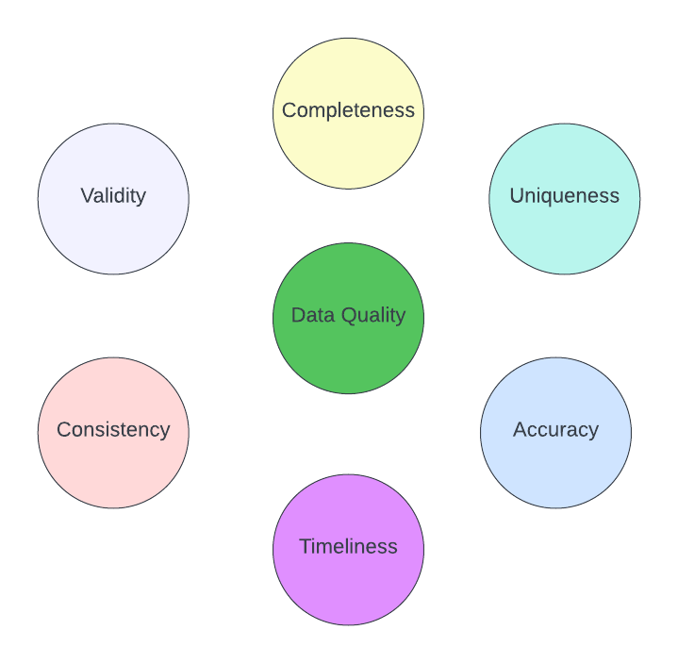

**Figure 13.** Data Quality assessing factors

1. **Completeness:**

Completeness refers to whether or not the dataset contains all of the relevant information or observations that are needed for a particular analysis or task.

We can see from the image data set that the geographical coordinates indicate the location of the image where it was taken and the date indicates the date the photo was taken, which is sufficient to get the image information, but it is our task to find the fire hydrant in the image using our ML model.

In the case of a dataset of fire hydrants in Fairfax County, completeness would refer to whether or not the dataset contains information on all of the fire hydrants in the county. It's important to note that achieving completeness can be challenging, and there may be various reasons why a dataset may not contain all of the relevant observations. For example, in the case of a dataset of fire hydrants, it may be difficult to locate and collect data on all of the fire hydrants in a county, especially if some fire hydrants are located in hard-to-reach or remote areas. Additionally, the dataset may only contain data on fire hydrants that are maintained or managed by a particular organization or agency, which may not include all fire hydrants in the county.

Therefore, it's important to carefully evaluate the completeness of a dataset and consider any limitations or biases that may be present. If the dataset does not contain all of the relevant observations, it's important to acknowledge this limitation and carefully consider the implications for any analyses or tasks that use the dataset.

Because we are still in the data preprocessing stage and cannot access all of the complete data due to its large size, determining the percentage of missing hydrants from the data set is difficult.

1. **Uniqueness:**

The uniqueness of a dataset refers to whether or not the data in the dataset is distinct or duplicated. In the case of a dataset of fire hydrants, uniqueness would refer to whether or not each observation in the dataset represents a distinct fire hydrant or if some observations represent the same fire hydrant.

If different images can capture the same fire hydrant, regardless of whether the coordinates are different, then there is a possibility of duplication in the dataset. However, the uniqueness of the dataset would depend on how the data is collected and how the dataset is structured.

If there are multiple images of the same hydrant, there is duplication; however, duplication in this context helps us to get clearer and more information about the fire hydrant rather than confusion, and there are some instances where there are multiple copies of the same image.

1. **Accuracy:**

The accuracy of data is determined by whether the data matches that found in the real world or another verifiable source.

The image dataset's above-mentioned details are correct, but this data set does not guarantee that all of the images in the dataset contain hydrants; there are images with and without hydrants. When we talk about images with hydrants, some images do not show the hydrant even though there is a hydrant in that location. This is due to a variety of factors such as fog, smoke, vehicle obstruction, image taken from a different direction, hydrant covered by snow, and sun rays blocking the view then these images are said to be inaccurate.

Images with fire hydrants are said to be more accurate if they are clear, high-quality, and accurately capture the condition and location of the fire hydrants.

As the dataset was collected by VDOT, we can assume that it was collected using standardized methods and equipment, which should help to ensure a certain level of accuracy. However, the accuracy of the dataset may still depend on several factors, such as the quality of the equipment used to capture the images, the conditions under which the images were taken, and the accuracy of the location data associated with the images.

In addition, since the dataset contains fire hydrants, there may be some degree of variability in terms of whether or not all images actually contain hydrants. It's possible that some fire hydrants may be missing from the images, or that the location data associated with the hydrants may not be entirely accurate.

To verify the accuracy of the dataset, we may have to perform a visual inspection of the images to check the location of the fire hydrants and compare the results with other sources of data or ground truth data. This can help identify any errors or inaccuracies in the dataset, which can then be corrected or flagged as potential issues.

**4. Timeliness:**

The timeliness of data refers to how current or up to date the information is. In other words, it's a measure of how recently the data was collected, recorded, or updated.

The VDOT imagery in your dataset was captured between 2018 and 2020, which means the data is 1 to 3 years old, depending on the specific image. since the images are from 2018, 2019, and 2020, then the data may be considered relatively recent but not necessarily the most current. It's possible that there have been updates or changes to the fire hydrants since the images were taken, which would make the data less timely.

Despite the fact that the data set we have is not timely, the ML model we are going to develop will detect the presence of hydrant and is not dependent on the time at which it was captured. However, the time at which it was taken provides us with clear information about the hydrant, which will be useful in developing the model.

**5. Consistency:**

A VDOT (Virginia Department of Transportation) imagery dataset's consistency can be determined by a number of factors, including:

1.metadata: Metadata contains information about the images, such as the date and time of capture, location, and camera settings.

2.Visual inspection: examining the images visually can reveal inconsistencies such as variations in brightness, contrast, and color. It compares the images and looks for differences using image processing software.

3.Georeferencing: Georeferencing is the process of aligning images with geographic data such as GPS coordinates or aerial imagery. We can check for consistency in location and scale by comparing the georeferenced images.

4.Statistical analysis: it is the mean and standard deviation of pixel values across multiple images to check for brightness and contrast consistency.

Because the camera used to capture the image and the VDOT vehicle used to collect the information about the fire hydrants are the same, we can say that our data set is consistent because the deciding factors for consistency are the same for all of the images.

**6. Validity:**

The image dataset we have got is in jpeg format which is valid format for data processing and apart from this the validity of the data is determined by how well the images capture the condition and location of the fire hydrants. If the images are clear, high-quality, and accurately capture the condition and location of the fire hydrants, then the data can be considered valid. However, if the images are blurry, low-quality, or do not accurately represent the fire hydrants, then the data may be less valid.

## Other Data Sources

The data source we have received is from VDOT images. The dataset we have got is mainly pictures of hydrants in different parts of Fairfax County. So, to look for other data sources we must ensure that the pictures we collect are up to date and are reliable. For this we came across a solution after talking to clients is to use Google Street View to collect the pictures because it is a live view so it will be up to date and can be reliable. In **Figure 11** and **Figure 12**, we can see pictures of two hydrants in two different streets that we have got using google street view. We are thinking of using the given data to train the model and use the collected data from Google Street View for testing the model.

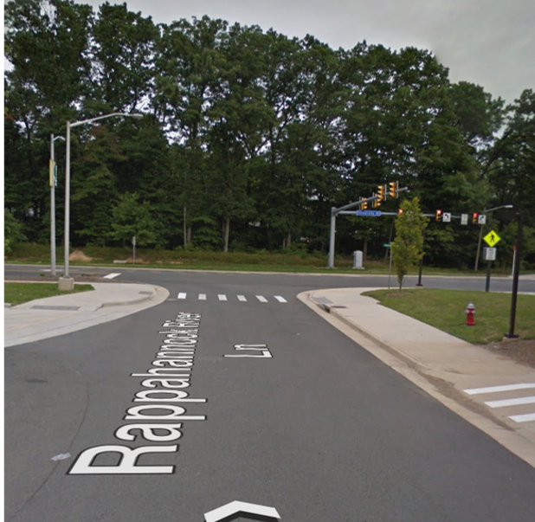

**Figure 14.** A picture of hydrant in Rappahannock Ln

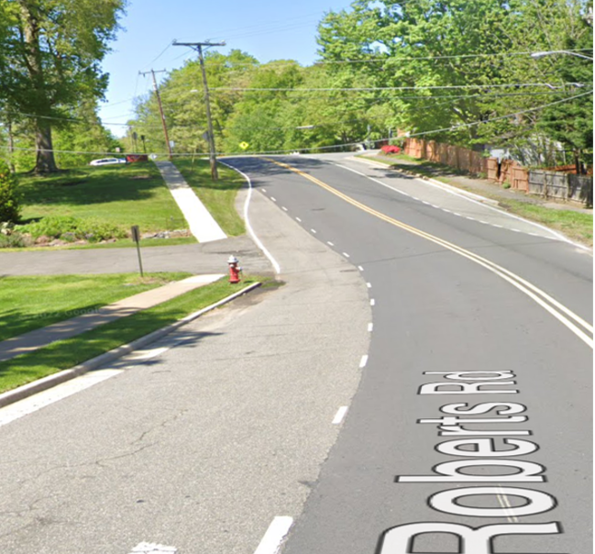

**Figure 15.** A picture of hydrant in Robert Rd

## Storage Medium

The dataset's size, complexity, and resources available for storing and processing the data all play a role in determining the data storage media for fire hydrant object detection. Hard Disk Drives (HDDs), Solid State Drives (SSDs), Cloud Storage, Network Attached Storage (NAS), External Hard Drives, and other devices are examples of potential data storage alternatives. We have a huge dataset for our project (size 288.3 GB). To store our dataset, we used Microsoft's OneDrive storage service. With the OneDrive storage system, you can view the data whenever you want, from anywhere. It also has strong security features and only allows access to certain people. Also, we utilized an HPC (High Performance Computing) cluster with a shared folder.

## Storage Security

An all-encompassing strategy that considers numerous facets of security, such as confidentiality, integrity, and availability, is needed to secure an image-heavy object recognition dataset and to prevent unauthorized access. We are using OneDrive as our storage medium. It is a cloud-based storage platform provided by Microsoft that can be used to store and share files online. Like other storage mediums, each file of OneDrive is encrypted with a unique AES256 key. All these unique keys are encrypted with a set of master keys that are stored in Azure Key Vault. The following actions can be taken to strengthen the security of the VDOT imagery:

1. Encryption: You can prevent unauthorized access to your object detection information by encrypting it with a powerful encryption method. The data might be encrypted while it is in transit, while it is being stored, or both. Ensure that the encryption keys are only accessible to those who are permitted. In our case, OneDrive already uses encryption, an extra layer of encrypting the image dataset improves security.
2. Backup and Disaster Recovery: To safeguard the dataset from unintentional loss, natural disasters, or cyber-attacks, you must have a backup and disaster recovery plan in place. To make sure data is protected against data loss or corruption, we must have a regular backup and restoration strategy, verify backups sometimes to make sure they are functioning properly.
3. Access Control: Incorporate access control mechanisms including role-based access control, two-factor authentication, and username/password authentication. This can help to guarantee that only authorized users can access the dataset for object detection.
4. Regular Audits: data stored on OneDrive can benefit from routine audits and vulnerability assessments that can help you spot any security problems early on and take appropriate action.
5. Secure Communication: Make sure that the dataset is delivered safely via encrypted channels and that the endpoints have the necessary authentication tools in place to confirm the sender's and receiver's identities. Consider enabling two-factor authentication (2FA) for the OneDrive account, which requires a second form of authentication in addition to the password.

These procedures can assist to ensure the security of our dataset by guarding it from unauthorized access, data breaches, and other security issues.

## Storage Costs

The size of the dataset given for our project is 288.3 GB. To store such a huge amount of data we have decided to use Microsoft One Drive. As our university provided us with Microsoft office 365 subscription which provides 1 TB storage it is free of cost during the period of this project.

# Algorithms & Analysis / ML Model Exploration & Selection

## Solution Approach

Developing a solution approach entail recognizing and resolving complicated issues through a methodical and controlled process. An in-depth comprehension of the issue and the development of a step-by-step strategy to achieve the intended result are necessary for a solution approach, regardless of whether it is used to produce a new product, optimize a process, or solve a societal issue. To ensure the effectiveness of the solution approach in this situation, it is necessary to use a variety of strategies and methodologies. By doing this, we may overcome obstacles, accomplish our goals, and help to improve the world. In this section we will talk about a method for detecting fire hydrants in a certain area using computer vision and machine learning techniques.

### Systems Architecture

The system architecture refers to the high-level structure and components of the system, including hardware, software, and network infrastructure. It describes how the system is organized and how its components interact with each other to achieve the desired goals.

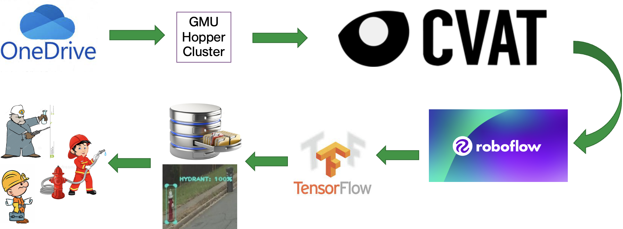

**Figure 16**. System Architecture

The high-level design of our project is shown in above figure. The images that constitute our dataset are stored in Microsoft's OneDrive cloud storage. Since our dataset is of huge size, we made use of GMU’S hopper cluster. Hopper cluster is a High-Performance Computing (HPC) Cluster with 12352 cores, 84 TB RAM and 40 NVIDIA A100 GPUS. The exploratory data analysis, preprocessing, and application of object detection models are performed on this dataset using this cluster. Using the CVAT tool, a portion of this data has been annotated for training and validation purposes. The result from CVAT is then used as an input by Roboflow to create the tf records needed for training. Jupyter Notebook IDE and the Python Virtual Environment are used throughout the entire process. TensorFlow, Keras, NumPy, Matplotlib, and Seaborn are the primary modules we are utilizing for the project. The final output of this project is the set of images where those images with hydrants have bounding boxes around hydrants. If any anomalies are discovered using this detection method, FCFRD can update their database of hydrants. The Fairfax County Fire and Rescue Department will primarily use this product, but city planners and water quality inspectors will also find it valuable.

In this project, we are dealing with a large amount of dataset which consists of 288.3 GB of images where we must use in the selected model, so we are using hopper Cluster for that. Hopper Cluster is used for high performance and the project file is restricted to others. The University is providing services regarding Hopper cluster where our team has access to the resources. We can only access through our University ID’s. Our team requires permission from the GMU ORC (Office of Research Computing) Administrator of the University to access the Hopper Cluster.

### Systems Data Flows

The system data flow, on the other hand, refers to the sequence of steps or processes involved in the data processing and information flow within the system. It describes how data moves through the system and how it is transformed or processed to produce the desired outputs.

Data

Collection

Data

preparation

Hopper

cluster

ML model

training

model

deployment

data quality and update

**Figure 17**. Data Flow

1.Data Collection:

* VDOT imagery dataset of pictures of hydrants in different parts of Fairfax County is collected and stored in OneDrive.

2.Data Preparation:

* A sample of data, such as 600 images, is taken from the dataset and labeled using a computer vision annotation tool (CVAT) then we used robo flow to create a data set of both images and annotated images, with the entire dataset divided into train, test, and validation datasets.
* The labeled data is stored in OneDrive.
* Exploratory data analysis (EDA) is performed on the sample data to ensure data quality and identify any data anomalies or biases.
* The images are Cropped and resized to a pixel size of 640 x 640 to fit the current model.

3.Hopper Cluster:

1. After collecting the image dataset and labeling it with CVAT and robo flow, we uploaded the previously saved efficient det model and the image dataset. Before uploading all of this, we created a virtual environment in which we installed tensor flow and loaded the required modules.

4.ML Model Training:

* The labeled dataset is used to train an ML model using TensorFlow.
* The trained model is saved and stored in OneDrive.

5.Model Deployment:

* The trained model is deployed to a cloud-based production environment, such as Microsoft Azure or Amazon Web Services.
* A RESTful API is used to allow other applications to interact with the model.
* Real-time data, such as images from Google Street View, is fed into the model for detection.

6.Data Quality and Update:

* Completeness, uniqueness, accuracy, timeliness, consistency, and validity are used as data quality dimensions to ensure the dataset is reliable and up to date.
* Automated data validation and cleaning techniques are used to improve data quality.
* The dataset is regularly updated with live data from Google Street View to ensure the model is up to date.

The system data flow involves collecting, preparing, training, deploying, and ensuring data quality and up-to-date information through live data updates.

While the system architecture and system data flow are related, they are different aspects of the overall system design. The system architecture provides the foundation for the system design and describes the key components and their interactions, while the system data flow describes how data flows through the system and how it is processed.

### Algorithms & Analysis

Algorithms and analysis play a crucial role in the development of a robust fire hydrant detection system. A precise and effective system that can identify the presence of fire hydrants in a specific region is crucial given the rising need for fire protection in urban settings. In this context, fire hydrants may be easily detected in photos using computer vision and machine learning approaches. To maximize the detection process and achieve high accuracy, the construction of such a system necessitates a solid understanding of numerous algorithms and analytic methodologies. In this section, we will see the data pre-processing steps, Exploratory Data Analysis (EDA), object detection algorithms and assessment methods that can be utilized to create a fire hydrant detection system.

Exploratory Data Analysis

Exploratory Data Analysis (EDA) is an essential step in any data-driven endeavor, including the detection of objects, must include exploratory data analysis (EDA). EDA can aid in comprehending the data's characteristics and potential challenges that might arise when trying to recognize hydrants with the image detection system.

All the images in the dataset are raw images taken directly from VDOT imagery and all of their properties are the same as seen I. All the images are of 1920 X 1080 dimension, with RGB color channels and the red channel value of pixel at (10, 20) is 248px.

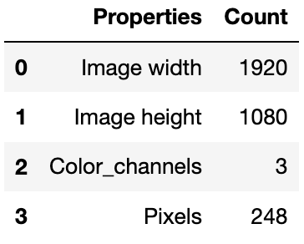

**Figure 18**. Image Properties

For instance, we have created a bar plot to know other stationary objects apart from hydrants in the given set of images.

We annotated (labeled using CVAT) a small part of image data to know about the other stationary objects that are confused with hydrants by the image detection system and the possibility of the presence of hydrants in all the images. It was observed that not all images have hydrants, approximately 30% of the images contain hydrants in it. From the below figures it can be observed that in both the years 2019 and 2020, there’s not much of a change in the number of hydrants. From this we can comprehend that not many or none of the hydrants were damaged or removed. There is a visible bias in the visualizations for 2019 and 2020, and this is due to the sample amount considered while labeling the images. From 2019 image dataset, almost 600 images were annotated, and 60 images were considered to look at the stationary objects in the year 2020.

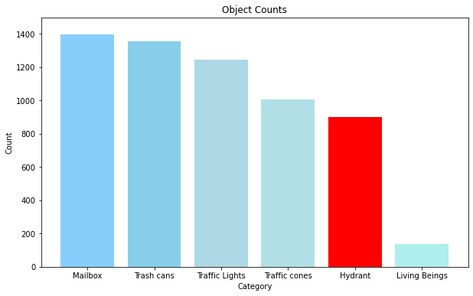

**Figure 19**. Objects that hydrants are often confused with

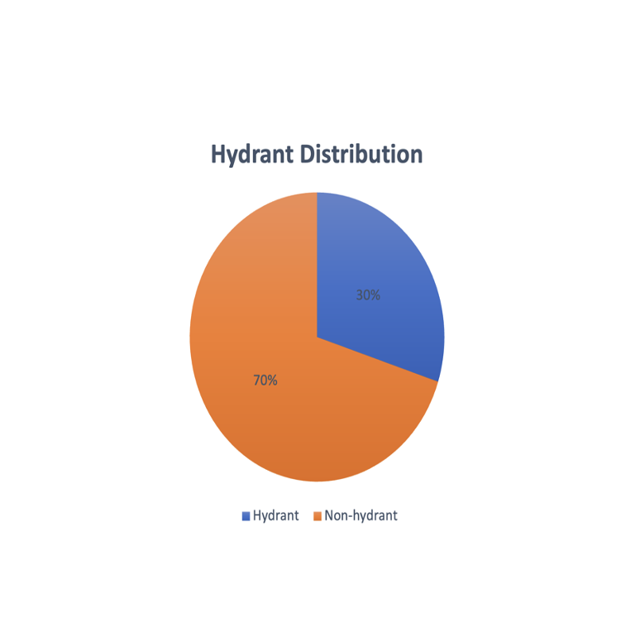

**Figure 20**. Percentage of images with and without hydrants (in the year 2019)

Annotated images that are stored as XML files were used to perform the above analysis, and these XML files are parsed using Element Tree library in python. shows the parsed XML files that are stored in a data frame.

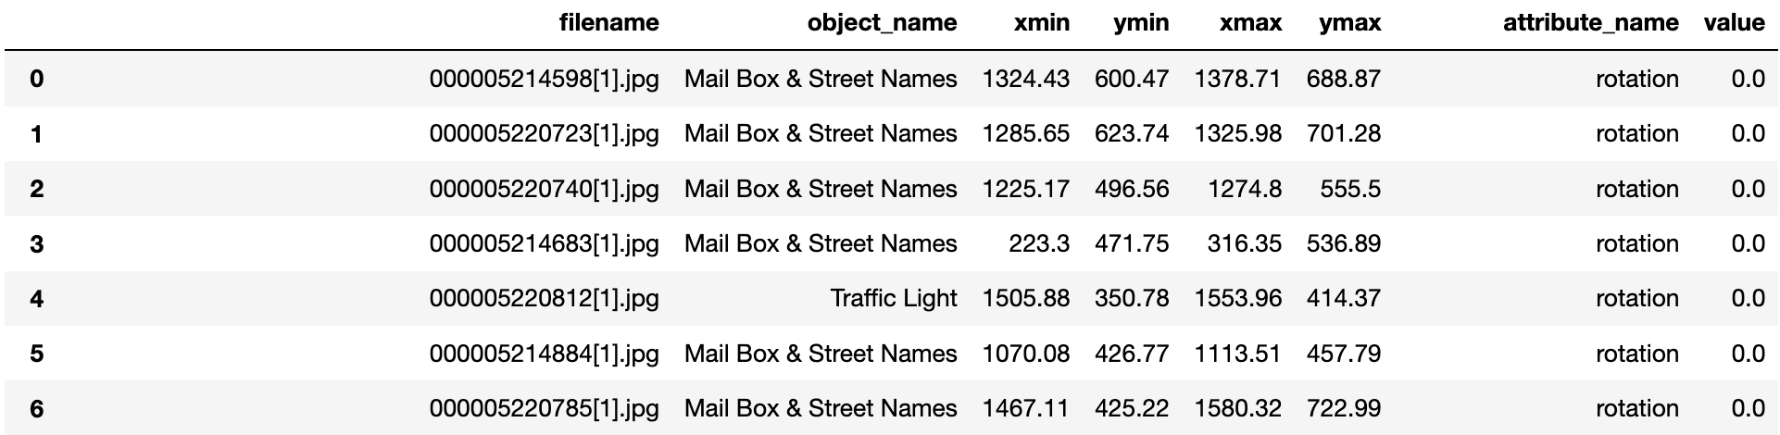

**Figure 21**. XML parsed files into a data frame

Almost all the hydrants in the images are of size: 1468.66, 1251.53, 519.83, 558.6 as xmin, xmax, ymin, ymax respectively.

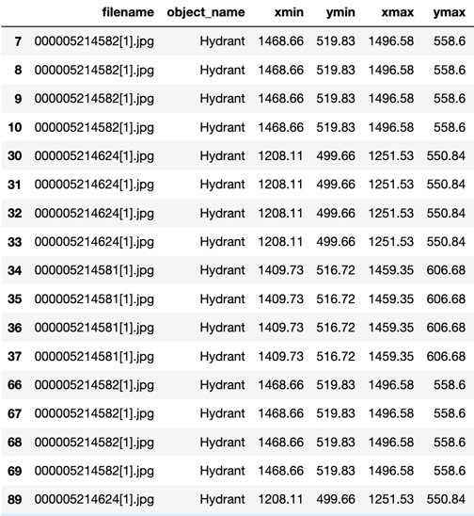

**Figure 22**. Data frame grouped by hydrant

Data Pre-processing

In any data analysis project, including the detection of fire hydrant objects, data pre-processing is an essential step. It entails data cleansing, transformation, and preparation in order to make the data appropriate for analysis. It is impossible to exaggerate how crucial data pre-processing is because it has a direct impact on how accurate and reliable any analysis is. Data pre-processing is crucial in the context of fire hydrant object recognition since it helps to ensure that the algorithms used to find fire hydrants are precise and efficient. We have come up with the following pre-processing steps to make the data suitable for our model.

**Image Cropping and Re-sizing**:

The development of a fire hydrant detection system requires the use of image cropping as a key technique. Cropping is the technique of picking out a specific area of interest within an image or video and deleting the surrounding area. In our project Cropping is used to eliminate unimportant background details and concentrate on the precise area where the fire hydrant is located. The object detection technique can be made more accurate and efficient by cropping the image to just contain the area of interest. For this we have cropped the top portion of the image to remove EXIF data and as hydrants are present on the ground, we are cropping the top part of the image and only considering the bottom part for detection. We also cropped the images into three separate images (Left, Middle, Right) so that we can concentrate on specific area in image where the hydrant is present and ignore other parts of the image. After cropping the image, we have resized the original image which is originally 1920 x 1080 into 640 x 640 in order to fit into our model.

dd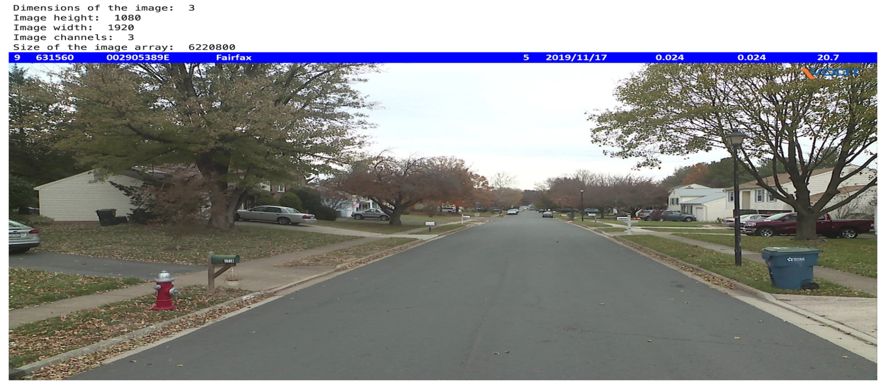

**Figure 23**. Original Image

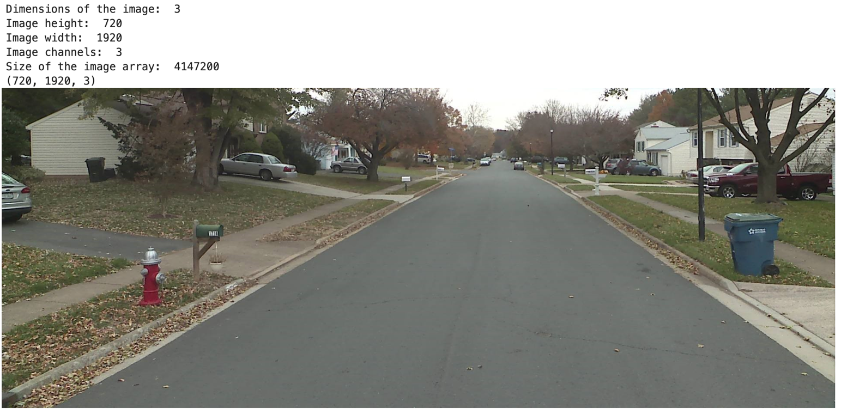

**Figure 24**. Cropped Image

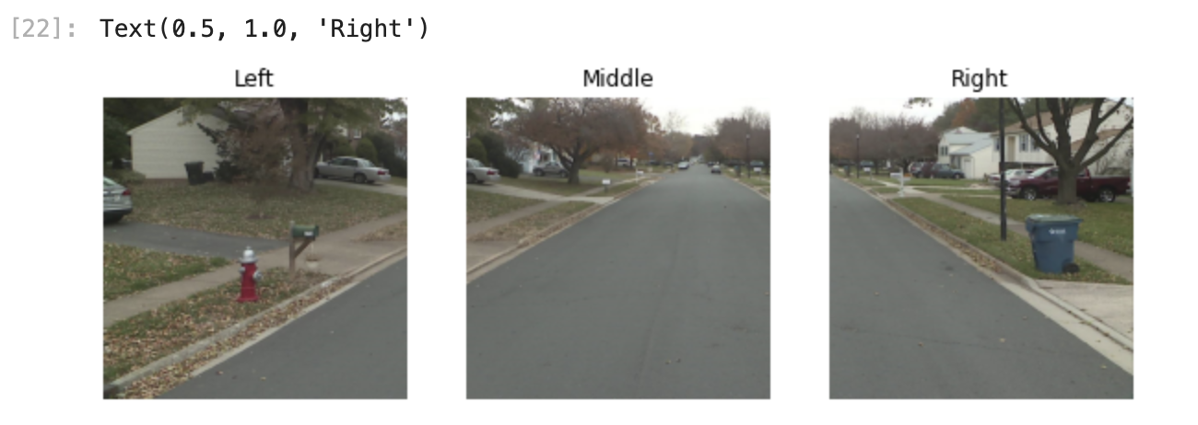

**Figure 25**. Cropped image into left, middle and right

The above images are of pixel dimension **720 X 720**. We then resize them into desired dimensions (for initial model implementation we have resized them to 640 X 640) to be able to fit them into the models.

## Machine Learning

### Model Exploration

The models we are exploring are Efficient Det, Faster R-CNN and Retina Net.

We explored the existing EfficientDet model that has a 2x-4x faster GPU and a 5x-11x faster CPU than other detectors. According to [6] EfficientDet model is an efficient model in object detection, fine tuning needs to be performed to improve the confidence score.

Mask R-CNN was explored taking [1] as reference but due to its low computational speed, we explored Faster R-CNN which overcomes the computational issue of Mask R-CNN.

Faster R-CNN and Efficient Det are two popular object detection models used in machine learning. One of the first models to employ a region proposal network (RPN) to create object proposals was faster R-CNN. The proposal is then put through a classifier to determine the object class and be refined. The model has obtained cutting-edge results on several benchmarks; however, it is somewhat slow when compared to more recent models.

We also explored the Retina Net model, a well-known object detection model that was released in 2017. Taking [7] as reference, we decided to employ Retina Net model to address the class imbalance issue in our dataset. While training, focal loss function gives harder samples more weight, which improves performance on classes of rare objects.

Retina Net is often quicker and more accurate than Faster R-CNN, especially recognizing small objects. On larger things, it might not work as well as it does on smaller ones. On the other hand, EfficientDet is more effective and produces greater accuracy than Retina Net.

After exploring the above models with the help of Jupyter notebook in Hopper Cluster to store, load and run the models, we’ve decided to compare the confidence score of all the models to identify the best detection model to detect hydrants. Once, all the models are set to run, we will observe the confidence scores to determine the model that performs best at object detection.

For our initial model implementation, we have used models which are pre-trained on COCO dataset. We are planning to implement the models by dividing our dataset into 70% training, 20% validation and 10% testing if we cannot achieve the desired confidence scores with the pre-trained COCO models.

### Model Selection

Initially, we employed the COCO pre-trained EfficientDet model to observe the confidence score. The model has detected multiple objects including:

Cars: Two cars in the scene were correctly identified by the model, and bounding boxes were drawn around them. The model's confidence in these detections is 89% and 76%, respectively.

Fire hydrant: The model correctly identified and bounded one fire hydrant in the scene. The model is 89% confident that the detected object is a fire hydrant, as indicated by the image's confidence value of 89%.

In the second image (right), the model correctly identified one fire hydrant in the scene and surrounded it with a bounding box. The confidence value for this detection is 94%, indicating that the model is 94% certain that the detected object is a fire hydrant.

Trash can: The model has not detected any other objects in the image.

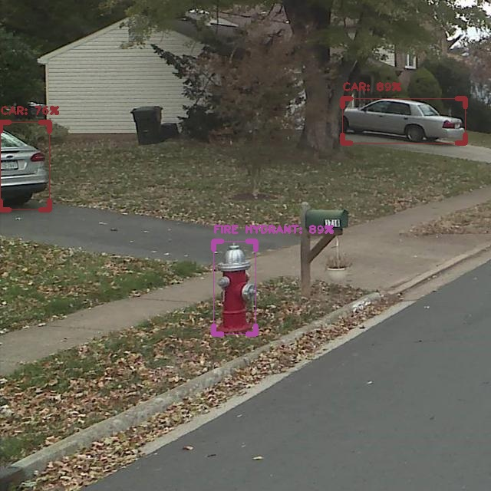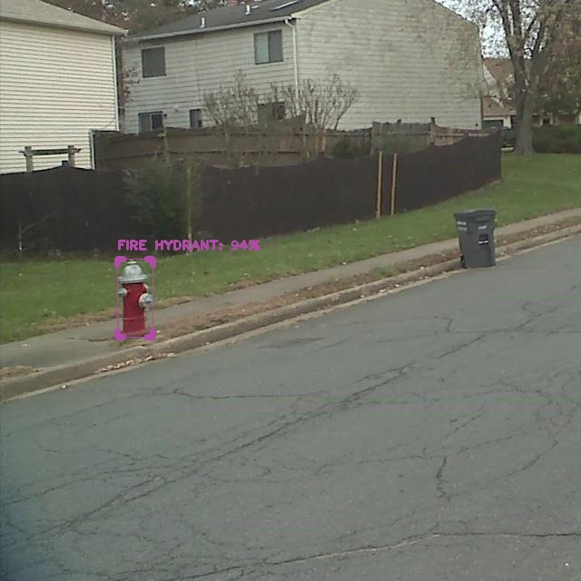

**Figure 26**. Hydrant detected with EfficientDet model

We have also tested the pre-trained Faster R-CNN model for some images from our dataset to test confidence score of the model. The model is detecting the hydrants with 100% confidence. So, we expect higher confidence from this model to detect hydrants for the whole dataset.

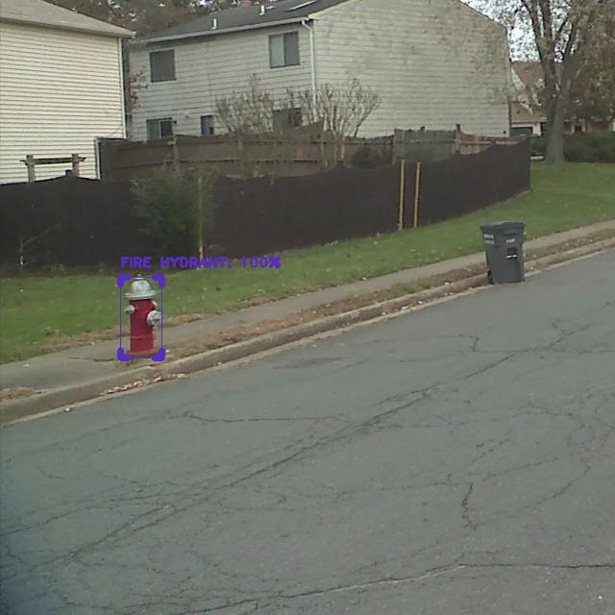

**Figure 27**. Objects detected with Faster R-CNN model

From our research above, we assumed Retina Net model will work well for this dataset because of the class imbalance. Retina Net has three versions for 640 X 640 format images. So, we used all three versions to detect hydrants.

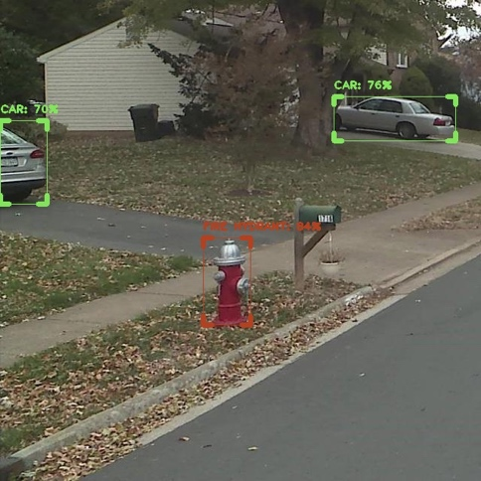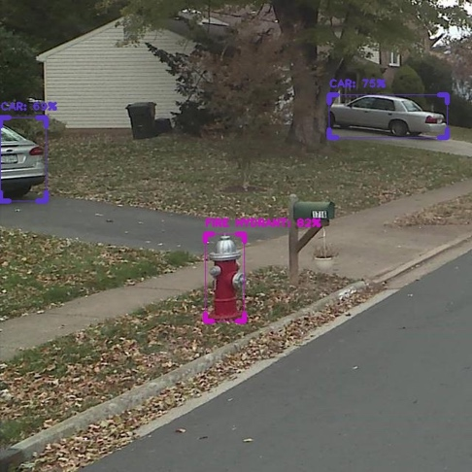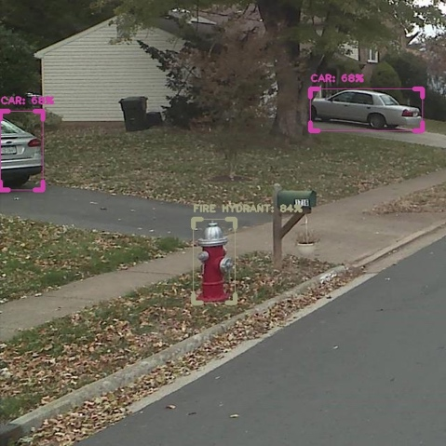

**Figure 28**. Hydrants detected with Retina Net versions 152 (left), 101 (center), 52 (right)

We observed that Retina Net has a low confidence score when compared to faster R-CNN. This is because, images with hydrants are near and larger, so Retina Net was not able to do well.

After comparing the three models (EfficientDet, Faster R-CNN and Retina Net), we identified that Faster R-CNN works well while detecting hydrants. Now that we know how the three models work, we will select Faster R-CNN model for training with our dataset.

# Visualizations / ML Model Training, Evaluation, & Validation

## Overview

We trained object detection models using TensorFlow and Roboflow, specifically the EfficientDet and Faster R-CNN models, on a dataset of annotated images of fire hydrants. Our team utilized Roboflow to generate a TF record dataset, which is compatible with TensorFlow's training models. Along with our custom models, we evaluated a pre-existing EfficientDet model provided by our client. However, this model struggled with correctly identifying fire hydrants, often mistaking them for traffic cones, trash cans, and traffic signals. We compared the performance of the models by analyzing the confidence scores of their detections. To train our models, we employed TensorFlow on the Hopper cluster, which is a high-performance computing cluster that provides access to powerful computing resources for data-intensive applications like machine learning, utilizing maximum of 4 GPUs and each GPU of maximum 40 GB RAM.

## Visualizations

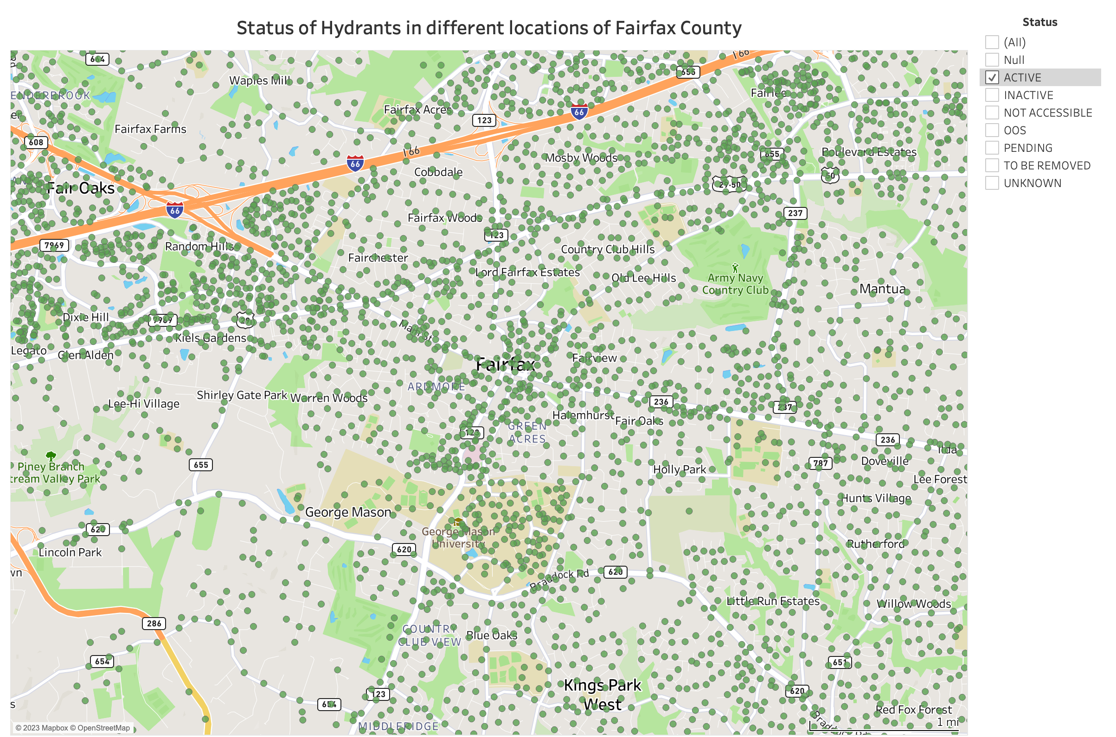

**Figure 29**. Active Hydrants represented on a street map

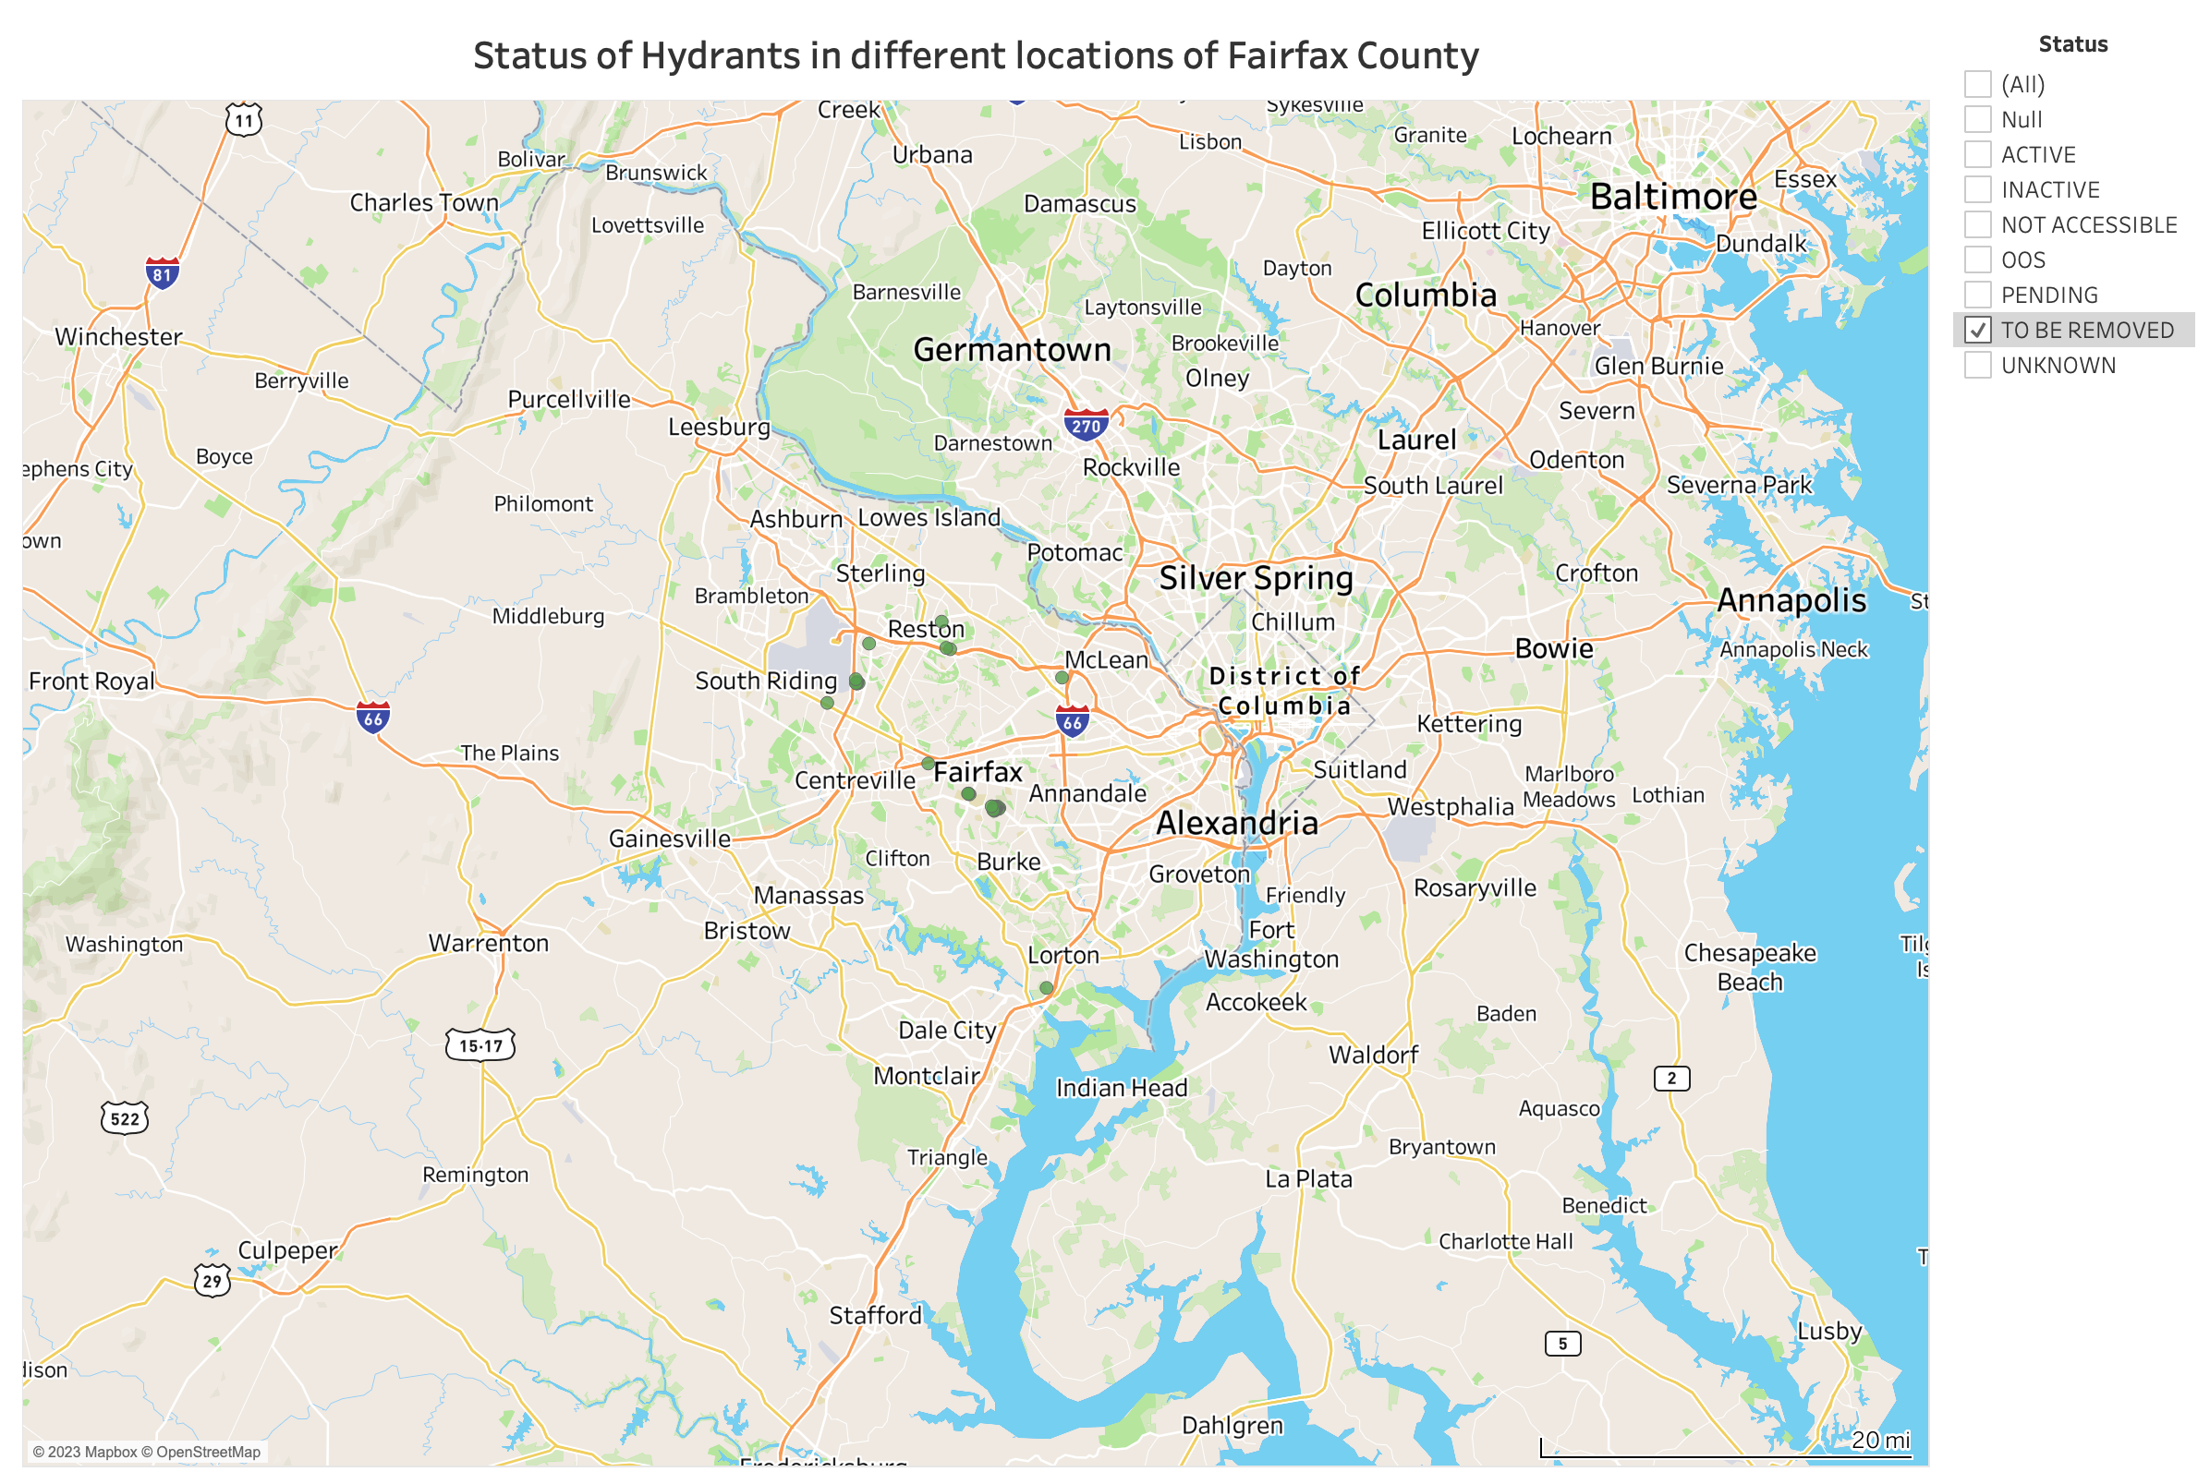

**Figure 30**. Hydrants to be removed represented on a street map

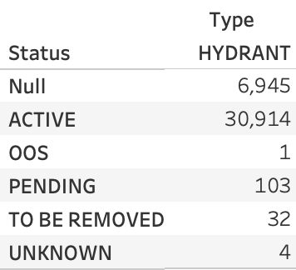

**Figure 31**. Status on the number of hydrants present

The above visualizations show the latest data Fairfax County Fire and Rescue Department are currently using in their production environment, and so it can be treated as what they would be relying on today to respond to fires.

Active - Hydrants located in those coordinates can be utilized.

Inactive - hydrant is not working but is intended.

Not accessible - hydrants in that location are present but not in reach during an emergency.

OOS - out of service, hydrant is not working, and not intended.

Pending - hydrants need to be installed in that location.

To be removed – hydrants are present but they need to be removed.

Unknown – status of the presence of hydrants is not known.

Null (Blanks) – none present.

## Machine Learning

Fire hydrant detection is a computer vision task that can be tackled using machine learning. Here are some steps we followed to develop a fire hydrant detection system using machine learning:

* Collected and prepared a dataset of images that contain fire hydrants. This is the data given by the fire department and this dataset is used for our project. The images from, this are collected by VDOT by mounting cameras on the vehicle.
* Annotated the images in dataset by drawing bounding boxes around the fire hydrants. We used a tool called CVT developed by INTEL which is an Image Annotator to do this.
* We split our dataset into training, testing and validation sets in the ratio of 70:20:10. The training set will be used to train machine learning model, while the testing and validation set will be used to evaluate and validate its performance. This process was done using a tool called Roboflow.
* We primarily Chose two machine learning algorithms Efficient DET and Faster R-CNN models to test and use for fire hydrant detection.

We trained our machine learning models on the training set using the chosen algorithm. This involve feeding the annotated images into the model and adjusting its parameters so that it learns to detect fire hydrants. We created tf records using the same tool to train our TensorFlow models using those records.

### Model Training

We began by annotating our images in the CVAT tool, only labeling fire hydrants. This provides labeled data that can be used for training a computer vision model to detect fire hydrants in input images.

As part of our image data management process, we used Roboflow to create a comprehensive dataset that consisted of both images and their corresponding annotations. This dataset was created using Roboflow’s annotation tools, which allowed us to easily annotate the images with object labels, bounding boxes, and other attributes.

Once the dataset was created, we exported it in the TFRecord format, which is a binary file format used by TensorFlow to store large amounts of data in a compressed and efficient manner. This format is particularly useful for working with image and annotation data in machine learning models.

We then used this dataset to train object detection models using two popular architectures, EfficientDet and Faster R-CNN. These models are designed to detect objects in images by analyzing various features of the input data and using machine learning techniques to identify and locate objects. We used both the models which are pre-trained on COCO dataset (a dataset containing 80 objects for detection), trained them on 800 annotated images (images labeled with hydrants). Training with more annotated images improved the performance of the models.

Overall, the combination of Roboflow for dataset creation and TFRecord format for data storage, along with state-of-the-art object detection models, provided us with a powerful toolset for training and deploying accurate object detection models for a variety of use cases.

After annotating the images, we uploaded both the annotated and original image data to Roboflow, which provides tools for managing and organizing data for computer vision projects. We used this tool to train and test our model. We divided the data into a training set (70%), validation set (20%), and testing set (10%) using Roboflow’s tools. This allows us to evaluate how well our model performs on new, unseen data (testing set) and to tune our model.

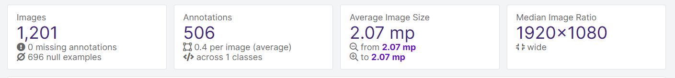

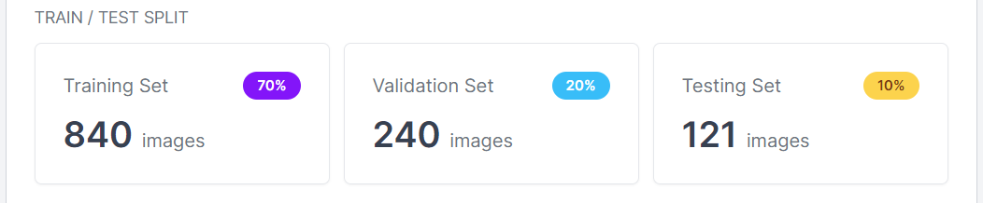

**Figure 32**. Roboflow image statistics and train/test split information

We resized the images to a size of 640x640, which is a common practice in computer vision. This allows for efficient processing of images while still maintaining a high level of detail.

After preparing our data, we trained and tested a Roboflow 2.o object detection model. Based on the training graphs, we achieved a mean average precision (mAP) of 91.3% and precision values of 89.1%. mAP is a commonly used metric for evaluating object detection models, which takes into account both the precision and recall values of the detections. A higher mAP indicates better performance. Precision is a metric that measures the proportion of true positives (correct detections) out of all the positive predictions made by the model. A higher precision indicates that the model is making fewer false positive detections.

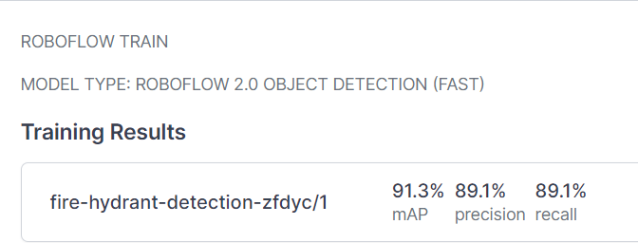

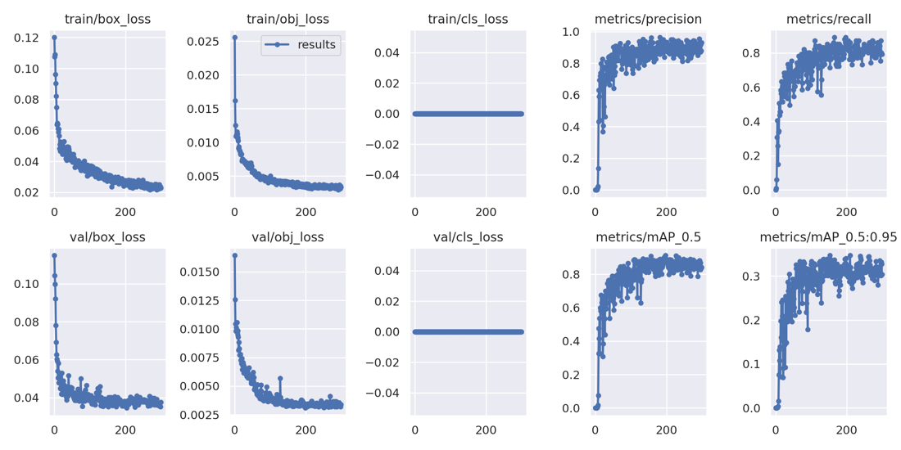

**Figure 33**. Roboflow training graphs

Overall, our progress in developing a computer vision model to detect fire hydrants in images seems to be good. However, there are many factors that can affect the performance of a model, including the size and quality of the dataset, the choice of model architecture, and the hyperparameters used during training.

### Model Evaluation

Initially, we tested three COCO pre-trained models EfficientDet, Faster R-CNN and RetinaNet101 and the results are seen below. It can be observed that Efficient Det and Faster R-CNN have the highest confidence scores. So, we have eliminated RetinaNet101 and went ahead only with Efficientdet and Faster R-CNN. Now that we filtered out the models that are suitable for our project, we have trained these models with our hydrant dataset.

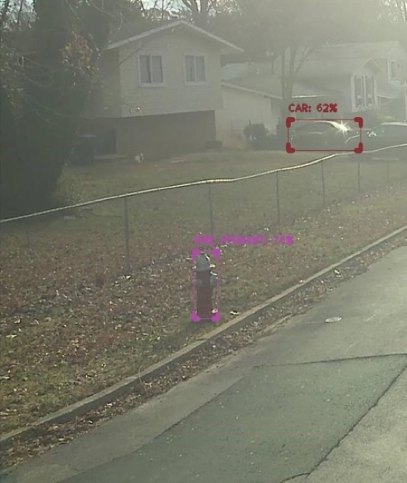 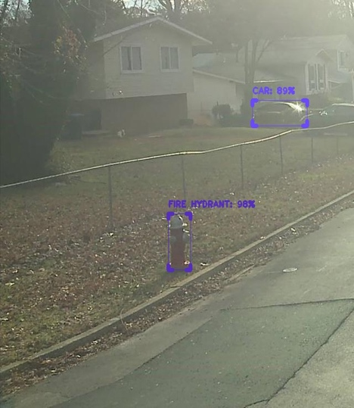 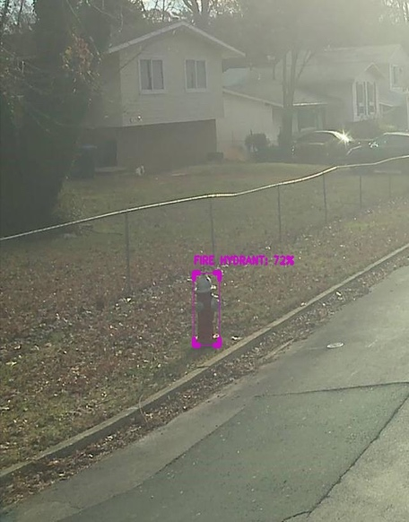

**Figure 34**. Comparison of the three models (EfficientDet, Faster R-CNN, RetinaNet101)

From our dataset, 3000 images out of which around 900 images contain hydrants were picked and split into 70% training images and 30% test images. The CVAT tool was used to annotate these images. The original pictures and xml files (annotation files) are input into the Roboflow tool, which creates the tf records needed to train models. The results of testing the trained model(provided by clients) are displayed below.

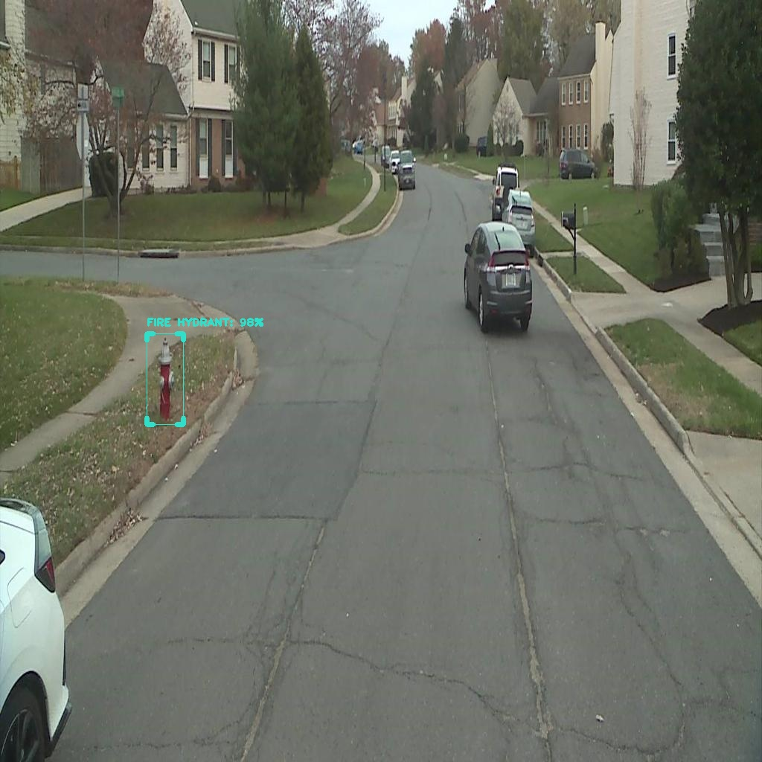

**Figure 35**. Client provided Efficientdet model detecting a hydrant

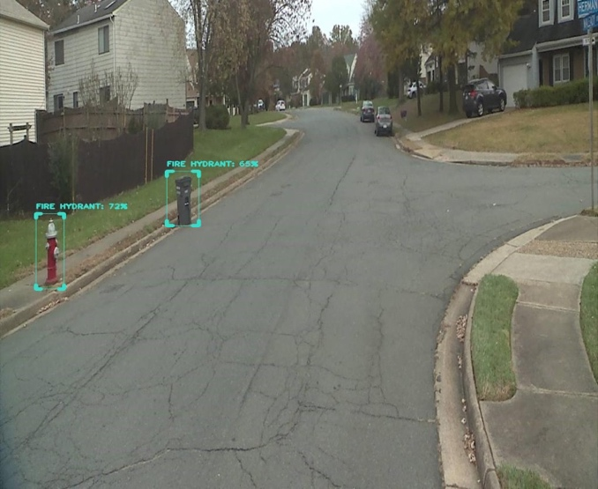 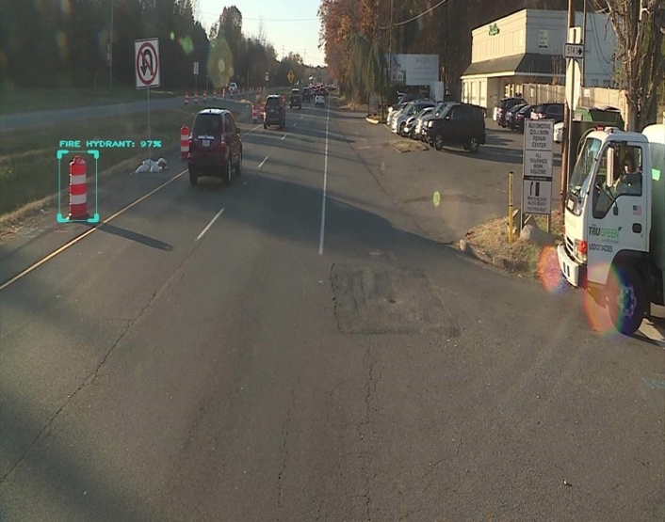

**Figure 36**. Client provided EfficientDet Model confusing traffic cone and trash can with a fire hydrant

The model detects objects that are similar to hydrants as hydrants, as you can see from the images above. So, the model needs to be finetuned further to correctly detect the hydrants. We evaluated the performance of our EfficientDet and Fast R-CNN models by preparing a separate test set of images that the models had not seen before. We then ran inference on the test set using the trained models to detect fire hydrants in the images, which produced predicted bounding boxes for each image. Next, we calculated the confidence score and mean Average Precision (mAP) metrics for each class using the predicted bounding boxes and ground truth bounding boxes from the test set. We used software tools like Object Detection API package to automate this process. We analyzed the results to understand how well our models were performing on the fire hydrant detection task and identified areas where they could be improved. Based on the analysis, we iterated the process by tweaking the hyperparameters, and collecting more training data until we were satisfied with the performance of our models. By following these steps, we were able to effectively evaluate the performance of our models and use the results to improve them over time.

To minimize number of false positives, we have annotated almost 3000 images out of which there were 900 fire hydrants and trained both the models Efficient Det and Faster RCNN with annotated data and we observed that the fine-tuned model EfficientDet did good job in differentiating hydrant-like objects and hydrants, but faster RCCN is still confusing with the traffic cone as a hydrant. The model’s performance has greatly increased and below we are showing a few samples of the same.

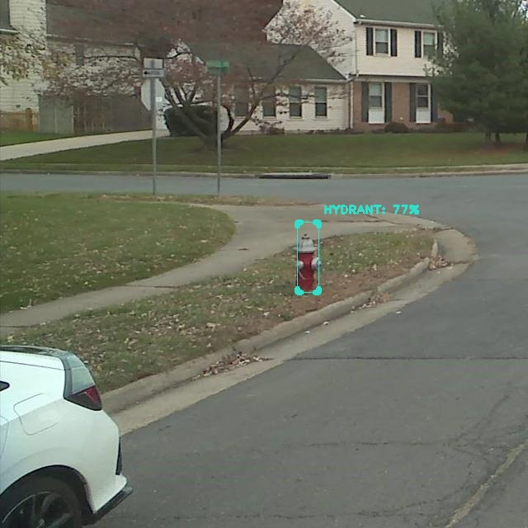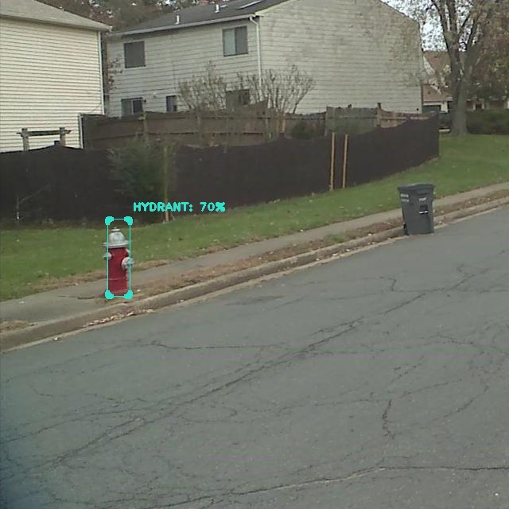

**Figure 37**. Re-trained EfficientDet model detection

We can see from above images that hydrant is detected and the Efficient Det model did not confuse the trash can as a hydrant as earlier. This is an improvement after training the model.

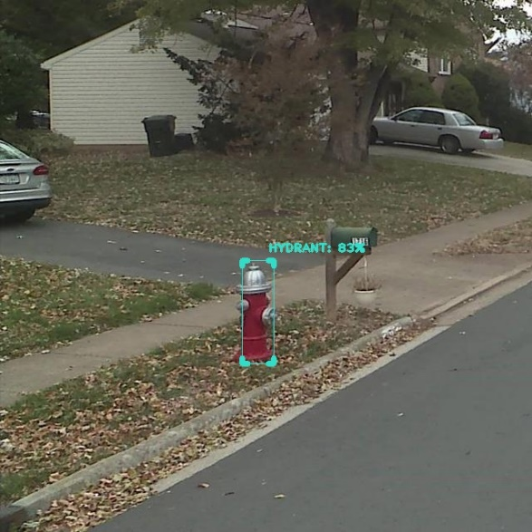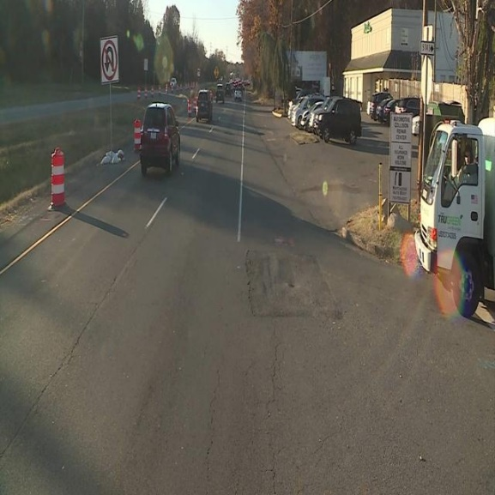

**Figure 38**. Re-trained EfficientDet model not confusing hydrants with other objects

From the above images we can see that hydrant detection is successful and the other image is with a traffic cone which looks like a hydrant, but the Efficient Det model did not detect it as a hydrant as earlier.

Now, we will look at Faster RCNN model which was trained with same number of images as the Efficient DET. We can observe from the results that Faster RCNN model detected the hydrants with more confidence rate than the other model and it also detects objects that are far in an image I.e., smaller images which Efficient Det cannot detect.

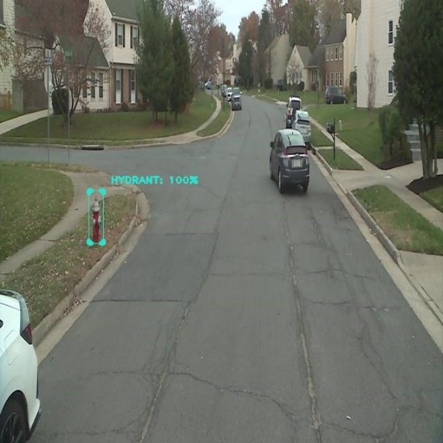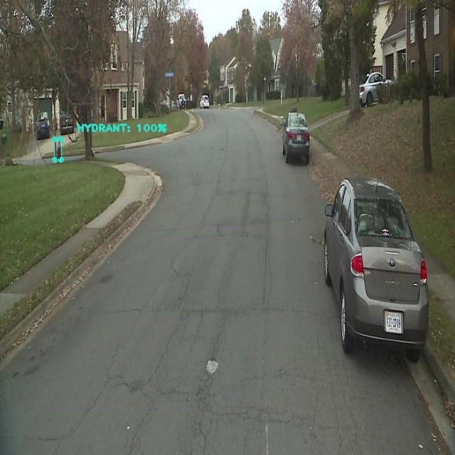

**Figure 39**. Re-trained Faster R-CNN model detection

We can see from above images that Faster RCNN detected the hydrants in an image with more confidence score than that of the other model and from second image we can see that it detected a hydrant that is far and smaller in an image with great confidence score.

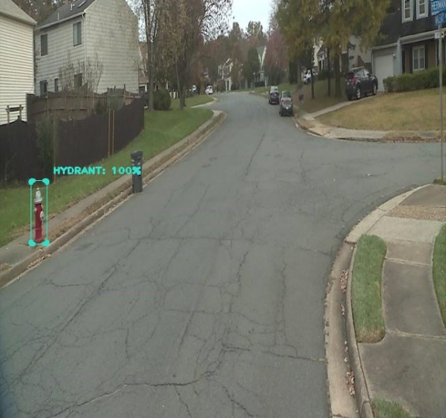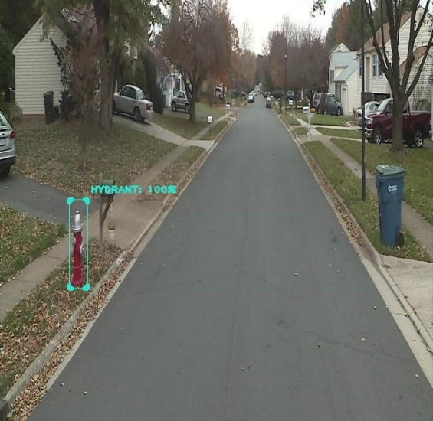

**Figure 40**. Re-trained Faster R-CNN not confusing hydrants with trash cans

The model detected the hydrants from above images correctly and Faster RCNN also does not confuse the trash can with hydrant and it detected hydrants with higher confidence than that of the other model.

We have drawn confusion matrix on 550 test images for both the models and the results are seen below.

**Confusion Matrix for EfficientDet (for hydrants)**

Actual

YES

NO

1

95

YES

Predicted

107

304

NO

At 50% Confidence threshold,

**Precision = 98.9%**

**Recall = 47.1%**

**Confusion Matrix for Faster R-CNN(for hydrants)**

Actual

YES

NO

7

154

YES

Predicted

48

298

NO

At 50% confidence threshold,

**Precision = 95.6%**

**Recall = 76.2%**

|  |  |  |  |  |  |
| --- | --- | --- | --- | --- | --- |
|  |  | Confidence Thresholds | | | |
|  |  | 20% | 35% | 40% | 50% |
| Model | Metric |  |  |  |  |
| Efficientdet | Precision | 97.40% | 98.30% | 98.20% | 98.90% |
| Recall | 76.20% | 57.90% | 55.40% | 47% |
| Faster R-CNN | Precision | 95.10% | 95.70% | 95.70% | 95.60% |
| Recall | 77.20% | 77.20% | 76.70% | 76.20% |

**Table 1**. Precision and recall values at various confidence thresholds

**LIMITATIONS WITH THE MODELS**:

Efficient DET:

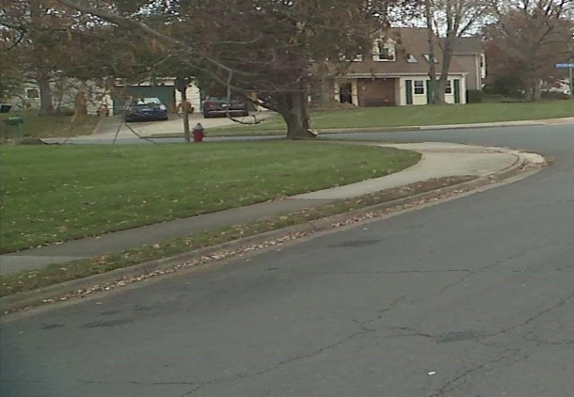

**Figure 41**. Re-trained EfficientDet model unable to detect faraway hydrants

* Efficient Det is not able to detect the hydrants that are far in an image and covered by sunlight.
* Lower confidence score is observed when compared with the Faster RCNN.

Faster RCNN:

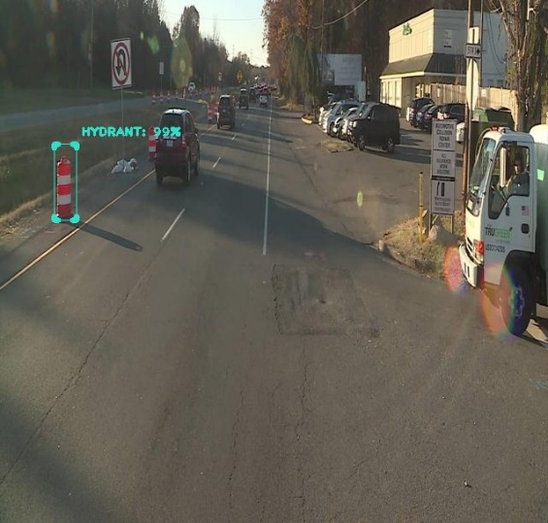

**Figure 42**. Re-trained Faster R-CNN confusing hydrant with a traffic cone

* The faster RCNN is confusing hydrant with a traffic cone from the above image. We need to fine tune this model further and bring more precision to the model.
* Faster RCNN is not able to detect images that are covered by sunlight.
* Both the models did not detect hydrants that are in sunlight.

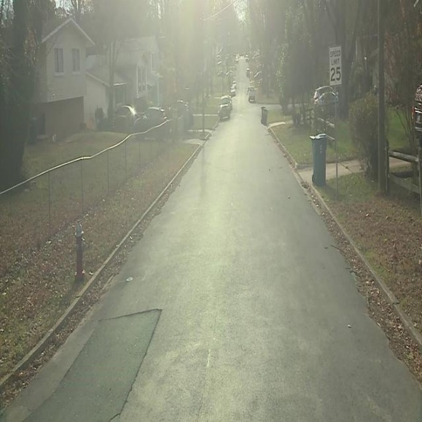

**Figure 43**. Re-trained models unable to detect hydrants in sunlight

### Model Validation

To validate the performance of a hydrant object detection model, several metrics such as precision, recall, F1-score, and mean average precision (mAP) can be used. Here's a detailed guide on how to validate the performance of a hydrant object detection model:

Prepare a validation dataset: Collect a set of images that contain hydrants and label the ground truth hydrant locations in each image. This step involves manually drawing a bounding box around each hydrant in each image and assigning a label to each bounding box. We have prepared a validation set of around 550 images to evaluate the model performance.

We aim to have a diverse set of images that cover a range of lighting conditions, angles, and distances. The size of the dataset will depend on the complexity of the problem and the amount of variation in the images.

Choose an evaluation metric: There are several metrics that can be used to evaluate the performance of an object detection model, such as precision, recall, F1-score, and mean average precision (mAP). We should choose the metric that is most appropriate for our use case. For example, if we need high precision to avoid false positives, then precision might be the most important metric. On the other hand, if we need to detect as many hydrants as possible, then recall might be the most important metric. We chose 550 images from the validation set and drawn confusion matrix for the selected models and calculated precision and recall for those models.

Choose a threshold: In object detection, the model outputs the coordinates of the bounding boxes around the detected hydrants, as well as a confidence score for each detection. We need to choose a threshold for the confidence score to determine whether a detection is considered positive or negative. A high threshold will result in fewer detections but higher precision, while a low threshold will result in more detections but lower precision. In our case, we need the model to detect all the hydrants present in images, so we consider low threshold value of 0.5 or 50%.

Run the model on the validation dataset: Use the model to make predictions on the validation dataset. The model should output the coordinates of the bounding boxes around the detected hydrants, as well as a confidence score for each detection.

Compute the evaluation metric: Use the ground truth labels and the model predictions to compute the chosen evaluation metric. For example, to calculate precision, count the number of true positives (TP), false positives (FP), and false negatives (FN) for each image, and use the formula TP / (TP + FP). As we have seen earlier, we calculated the precision and recall for both the models and observed that EfficientDet has higher precision(**98.9%**) whereas Faster R-CNN has higher recall(**76.2%).** Precision difference of 3.3% is observed between the models.

Analyze the results: After computing the evaluation metric, we should analyze the results to identify the strengths and weaknesses of the model. For example, we might find that the model has a high precision but a low recall, which means that it's good at identifying hydrants but misses some instances. We should also look at the confusion matrix to see which classes the model is confusing with hydrants. We can visualize the model's predictions on the validation dataset to see which hydrants the model is detecting correctly and incorrectly. From our results, we found that Faster R-CNN to be better between the two because it has good precision and recall values.

Fine-tune the model: Based on the analysis of the results, we can fine-tune the model to improve its performance. For example, we increase the size of the training dataset, adjust the model architecture, or change the hyperparameters like training steps for checkpoints, batch size. In our case, we retrained both the efficientdet and Faster R-CNN models after annotating the traffic cones that the Faster R-CNN model most frequently confused with. After testing these retrained models, we found that they continued to become increasingly confused and mistakenly identified almost all traffic cones as fire hydrants. Therefore, we have disregarded this fine-tuning option. We have added this fine-tune option in the future work.

# Findings

This project suggests that manual annotations can enhance the performance of the model by achieving a gain of 23% in average confidence score. When tested on 550 images, the faster R-CNN model demonstrated precision of 95.6% and recall of 76.2%, whereas Efficientdet provided precision of 98.9% with recall of only 47.1%. The careful and accurate labeling of images can significantly improve the model's ability to learn and perform well. Additionally, the EfficientDet model showed superior performance when trained with a larger number of images, indicating that increasing the size of the training dataset can lead to better results. However, it is important to note that even models with consistently high performance, such as the Faster R-CNN with a confidence score of 96% can still suffer from confusion between objects if not trained with enough images. Specifically, this model may confuse hydrants with traffic cones if not adequately trained, highlighting the need to ensure that models are trained with an adequate number of images to avoid such errors. Overall, these findings emphasize the importance of careful labeling and training with a sufficient number of images for successful machine learning model performance.

# Summary

The research paper describes the development of an automated hydrant detection system aimed at improving emergency response times during fire outbreaks. The study utilizes image data collected by the Virginia Department of Transportation to maintain an accurate hydrant database for the Fairfax County Fire and Rescue department. The researchers examined various object detection methods and found that pre-trained COCO models EfficientDet and Faster R-CNN have high performance when applied to the hydrant image dataset. After fine-tuning both models using 3000 manually annotated images, the Faster R-CNN model was found to have the best performance, achieving an average confidence score of approximately 96%. This represents a 23% gain in average confidence scores compared to the EfficientDet model originally trained on only 400 images. The improved performance of the automated hydrant detection system will lead to a more reliable fire hydrant database, enabling first responders to locate hydrants more efficiently and reducing emergency response times.

# Future Work

The performance of the hydrant detection system can be improved by exploring several approaches. One approach is to annotate more images to increase the diversity of the training dataset. Another approach is to experiment with different architectures or training procedures, such as transfer learning, to improve the model's ability to learn from the available data. Choosing a different performance matrix other than precision or recall that has been considered in this project to evaluate and compare the performance of both the models.

The tool can serve the Fire Department's needs by minimizing response times for each call and reducing the total human labor required to maintain and update the database. The ultimate goal could be to alert the Fire Department every time the model detects a discrepancy between the hydrant database and the latest imagery available. To achieve this, the tool can be integrated into the Fire Department's existing workflow, and future data analytics work may be required to refine the tool's accuracy and effectiveness.

Data augmentation can be a useful technique for improving the performance of a hydrant object detection model which is trained on very few labeled data but is expected to perform well with unseen/new data. This additional step can help address the problem by creating new training examples from the existing labeled data, thereby increasing the effective size of the training set.

In addition to detecting hydrants in images, the next step is to track their location and changes over time. This can be achieved by building an automated system that can track hydrant location changes over time by extracting and comparing geo-location information from new images. If hydrants match the existing database, they're marked validated; if not, they're flagged for review. The database is updated with validated locations to improve the detection model's accuracy. By implementing these steps, the availability and status of hydrants can be tracked with greater precision, providing valuable information for the Fire Department's operations.

Appendix

Appendix A: Glossary

|  |  |
| --- | --- |
| Term | Definition |
| Annotation | Annotation is the process of labeling or adding metadata to data, such as images, videos, or text, to provide context and make it more useful for machine learning and other applications. |
| Azure Key Vault | Azure Key Vault is a cloud-based service offered by Microsoft Azure that provides secure storage and management of cryptographic keys, secrets, and other sensitive data. |
| Bi-Directional Feature Pyramid | Bi-Directional Feature Pyramid (BDFP) is a computer vision model that uses a bi-directional top-down and bottom-up feature pyramid to improve object detection and segmentation performance on images and videos. |
| Bounding Box | A bounding box is a rectangular box that encloses or surrounds an object or region of interest in an image or video, typically used for object detection, localization, and tracking in computer vision tasks. |
| Classifier | A classifier is a machine learning model that assigns a label or category to a given input data based on learned patterns and rules from the training data. |
| Computer Vision | Computer vision is a field of study focused on enabling computers to interpret and understand visual information from the world around them. |
| Confidence Score | Confidence score, in machine learning, is a probability value assigned to a predicted class label by a model, indicating the level of certainty or confidence in the prediction. |
| CVAT | CVAT (Computer Vision Annotation Tool) is an open-source web-based tool for annotating digital images and videos, typically used for training machine learning models in computer vision tasks. |
| Deep Learning | Deep learning is a subset of machine learning that uses neural networks with many layers to model complex patterns in data, achieving state-of-the-art performance on tasks such as image and speech recognition. |
| EXIF Metadata | EXIF metadata is information embedded within a digital image file that contains details such as camera settings, date and time, and location where the photo was taken. |
| F1-Score | F1-score is a metric in machine learning that combines precision and recall into a single score by taking their harmonic mean, providing a balanced measure of a model's performance that accounts for both false positives and false negatives. |
| Feature Map | A feature map is a visual representation of the output of a convolutional neural network layer, containing learned features and patterns extracted from an input image or data. |
| Feature Pyramid Network | A Feature Pyramid Network is a computer vision model that uses a multi-scale feature representation to detect objects at different scales and levels of abstraction in an image or video. |
| Fine tuning | Fine-tuning is a machine learning technique that involves adjusting a pre-trained model's parameters on a new dataset, typically with smaller amounts of data, to improve its performance on a specific task. |
| Geo Spatial Localization | Geospatial localization is the process of identifying the geographic location of an object, device, or event using spatial data and analysis techniques. |
| Hopper Cluster | A hopper cluster is a group of computing nodes that work together to perform a large-scale parallel computing task, typically used in high-performance computing and scientific applications. |
| Hydrant | A fire hydrant is an above-ground connection point to a water supply that firefighters use to access pressurized water for extinguishing fires. |
| Hydrant Mapping | Hydrant mapping is the process of creating a digital map or inventory of fire hydrants in a specific area for quick and efficient access during emergencies. |
| Image Pre-Processing | Image pre-processing is a set of techniques used to prepare digital images for analysis, typically involving operations such as noise reduction, image enhancement, and image normalization. |
| Image Resolution | Image resolution is a measure of the amount of detail in a digital image, typically expressed in terms of the number of pixels in the image. |
| Loss Function | A loss function is a mathematical function that measures the difference between predicted values and actual values in a machine learning model, serving as a guide for the model to improve its predictions. |
| Machine Learning | Machine learning is a subset of artificial intelligence that involves training algorithms to learn patterns and make predictions or decisions based on data, without being explicitly programmed. |
| Machine Learning Model | A machine learning model is a mathematical representation of a system or process that can make predictions or decisions based on input data. |
| Mean Average Precision | Mean Average Precision (mAP) is a commonly used metric in object detection and image retrieval tasks that measures the accuracy of a model in detecting and localizing objects in an image or video by averaging the precision scores at different levels of recall. |
| Model Evaluation | Model evaluation is the process of measuring the performance and accuracy of a machine learning model on a test dataset, using metrics such as accuracy, precision, recall, and F1-score. |
| Multi-Scale Feature Fusion | Multi-Scale Feature Fusion is a computer vision technique that combines features from multiple scales of an image or video to improve object detection, segmentation, and other visual recognition tasks. |
| Neural Network | A neural network is a type of machine learning model inspired by the structure and function of the human brain, composed of interconnected nodes or neurons that process and transmit information to make predictions or decisions based on input data. |
| Object Detection | Object detection is a computer vision technique that involves identifying and localizing objects within an image or video. |
| Object Localization | Object localization is a computer vision task that involves identifying the location of objects within an image or video by drawing a bounding box around them. |
| Precision | Precision is a metric in machine learning that measures the proportion of true positive predictions out of all positive predictions made by a model, indicating how accurate the model is when predicting positive labels. |
| Recall | Recall is a metric in machine learning that measures the proportion of true positive predictions out of all actual positive instances in the dataset, indicating how well the model is able to identify positive instances. |
| Sliding Window | A sliding window is a computer vision technique that involves moving a window of fixed size across an image or video to perform object detection or segmentation at multiple locations and scales. |
| TF Record | TF Record is a file format used in TensorFlow for storing large datasets of serialized binary data, typically used for efficient input pipelines in machine learning models. |
| Validation | Validation, in machine learning, is the process of evaluating a trained model on a separate dataset to assess its performance and generalize its ability to make predictions on new, unseen data. |

Appendix B: GitHub Repository

Overview

Hydrant Object Detection is a deep learning project that aims to detect and classify fire hydrants in images using convolutional neural networks (CNNs). The project is built using Python and TensorFlow, a popular open-source library for machine learning.

The project includes a dataset of annotated images of fire hydrants, which was used to train the CNN models and images were used to test the performance of the model. The code includes a script for training the models, which leverages the pre-trained EfficientDet and Faster R-CNN models.

The README file provides a detailed guide on how to set up the environment and run the scripts for training and testing the model. It also includes instructions on how to use the pre-trained model to detect and classify fire hydrants in new images.

Overall, Hydrant Object Detection is a useful tool for firefighters, city planners, and others who need to locate and map fire hydrants in their communities.

GitHub Repository Link

[GitHub Repository Link](https://github.com/Vaishnavi0804/Hydrant-Object-Detection)

GitHub Repository Contents

README.md

EDA.ipynb

Model training, testing & evaluation.ipynb

Preprocessing_step-1.ipynb

data_parsing.ipynb

Appendix C: Risks

Sprint 1 Risks

|  |  |  |  |  |
| --- | --- | --- | --- | --- |
| **Risk Name** | **Description** | **Probability** | **Impact** | **Mitigation** |
| Detection Challenge | Pictures having hydrants covered in snow / shade, lack of image quality | Medium | High | Improve the existing model to increase the accuracy |

Sprint 2 Risks

|  |  |  |  |  |
| --- | --- | --- | --- | --- |
| **Risk Name** | **Description** | **Probability** | **Impact** | **Mitigation** |
| Uniqueness | Multiple copies of same hydrant | High | High | Identify and segregate images with same or nearby coordinates |
| Hopper Cluster | GMU ORC might be down due to maintenance or other planned activities | Low | High | Plan ahead when GMU ORC sends out an email of maintenance |

Sprint 3 Risks

|  |  |  |  |  |
| --- | --- | --- | --- | --- |
| **Risk Name** | **Description** | **Probability** | **Impact** | **Mitigation** |
| Permission denial | Folders created by individuals need separate permissions for all the members of the team to access that folder | Low | Low | Give full access to only the respective team (Do not make it public) |
| Slow data transfer | Each Gb data is taking about an hour to upload onto the hopper cluster | High | Medium | Reach out to the ORC office, meanwhile, try to get most of the analysis from the existing data |

Sprint 4 Risks

|  |  |  |  |  |
| --- | --- | --- | --- | --- |
| **Risk Name** | **Description** | **Probability** | **Impact** | **Mitigation** |
| Hopper compatibility and resource allocation | Installing all the required libraries or frameworks needed for model execution | High | High | Install all the libraries needed before executing the models |

Sprint 5 Risks

No risks identified.

Appendix D: Agile Development

Agile development is a software development methodology that emphasizes flexibility, collaboration, and continuous improvement. In agile development, teams work in short iterations or sprints, typically lasting three weeks, to deliver working software that meets customer requirements.

Scrum Methodology

Scrum methodology worked well for the project. To start with, roles and responsibilities of a Scrum Master and a Product Owner were decided. Scrum Master facilitated the scrum process and ensured that the team was following the methodology. Product Owner was responsible to communicate with the client and the team to decide on the features needed for the project. The development team is responsible for the actual development and testing of the model.

Adapting to the Scrum methodology was not too difficult as the project started with a sprint planning meeting, where the tasks for that sprint were identified, estimated the effort required for each task and created cards needed for that sprint, also defined the definition of done to meet the sprint goals. Short and focused scrum calls were conducted every morning to discuss the project’s progress, identify any obstacles, and plan tasks for the day. All the task cards are created in respective swimlanes along with identifying the user stories.

Overall, the Scrum methodology and the YouTrack tool helped in delivering the project on time and within budget, with positive feedback from Fairfax Fire and Rescue Department.

Sprint 1 Analysis

During the first sprint, main focus was on defining the problem, identifying the scope of the project, creating a shared understanding of the project goals and objectives, and identifying potential stakeholders who would be impacted by the project. Our team also identified various risks and came up with solutions that could work to minimize or handle the risks. The team learned the importance of understanding the difference between a classification and a detection problem through the research.

Sprint 2 Analyis

In this sprint, our team focused on acquiring and installing the necessary libraries for executing the existing EfficientDet model. We identified the preprocessing needed for each model and worked on acquiring and cleaning the images accordingly. Our team also established data quality and completeness criteria and worked to ensure that the data met these criteria.

Sprint 3 Analysis

During this sprint, our team focused on selecting the appropriate algorithms and techniques to be used in the analysis of the image dataset. We explored different machine learning models like Mask R-CNN, YOLO, EfficientDet, Fast R-CNN, RetinaNet and identified the ones that would be most appropriate for our project objectives. The team also worked on developing an understanding the performance metrics that would be used to evaluate the effectiveness of the models.

Sprint 4 Analysis

In this sprint, our team focused on training and evaluating the machine learning models, as well as visualizing the results of trained models. The team was successful in executing both EfficientDet and Faster R-CNN models. Upon comparing their results, the team uncovered that Faster R-CNN is a model with high performance, unlike EfficientDet, which was good at detecting hydrants but with low confidence. However, the team identified that Faster R-CNN model is confusing hydrants with traffic cones.

Sprint 5 Analysis

During the final sprint, our team focused on preparing the final report and presentation for the project. we worked on integrating the results of the analysis into a coherent report and developed a presentation to showcase the results to stakeholders. Our team also worked on preparing documentation and other materials to support the ongoing use and maintenance of the project.

Throughout the entire Agile Development process, our team utilized the principles of Agile methodology, including regular check-ins, frequent iteration and feedback, and continuous improvement. We also used Agile tools such as daily stand-up meetings to keep everyone on the same page and ensure that the project was progressing as planned. Our team was able to deliver a successful project that met the objectives and requirements of the stakeholders.

Reference

# Works Cited

|  |  |
| --- | --- |
| [1] | A. F. Gad, "Object detection using mask R-CNN with TensorFlow," 09 April 2021. [Online]. Available: https://blog.paperspace.com/mask-r-cnn-in-tensorflow-2-0/. [Accessed 10 February 2023]. |
| [2] | H. Kim and Y. Ham, "Participatory sensing-based geospatial localization of distant objects for disaster preparedness in urban built environments," *Automation in Construction,* vol. 107, p. 102960, 2019. |
| [3] | A. Rosebrock, "PyImageSearch," 13 May 2022. [Online]. Available: https://pyimagesearch.com/2018/11/12/yolo-object-detection-with-opencv/. [Accessed 10 February 2023]. |
| [4] | S. "Programmathically," 22 May 2022. [Online]. Available: https://programmathically.com/foundations-of-deep-learning-for-object-detection-from-sliding-windows-to-anchor-boxes/. [Accessed 10 February 2023]. |
| [5] | "(PDF) pyramid methods in image processing - researchgate," [Online]. Available: https://www.researchgate.net/publication/246727904_Pyramid_Methods_in_Image_Processing. [Accessed 10 February 2023]. |
| [6] | M. Tan, R. Pang and Q. V. L. , "arXiv," arXiv, 20 Nov 2019. [Online]. Available: https://arxiv.org/abs/1911.09070. [Accessed 27 Jul 2020]. |
| [7] | T.-Y. Lin, P. Goyal, R. Girshick, K. He and P. Dollár, "arxiv," 7 Aug 2017. [Online]. Available: https://arxiv.org/abs/1708.02002v2. [Accessed 7 Feb 2018]. |
| [8] | "Injury Facts," 11 May 2023. [Online]. Available: https://injuryfacts.nsc.org/home-and-community/safety-topics/fire-related-fatalities-and-injuries/. [Accessed 17 October 2022]. |
| [9] | N. A. Ahmed, "Kili," [Online]. Available: https://kili-technology.com/data-labeling/machine-learning/mean-average-precision-map-a-complete-guide. [Accessed 12 May 2023]. |
| [10] | A. Anwar, "Towards Data Science," 12 May 2022. [Online]. Available: https://towardsdatascience.com/what-is-average-precision-in-object-detection-localization-algorithms-and-how-to-calculate-it-3f330efe697b. [Accessed 12 May 2023]. |
| [11] | E. Odemakinde, "viso.ai," 11 May 2023. [Online]. Available: https://viso.ai/deep-learning/mask-r-cnn/#:~:text=The%20reason%20why%20%E2%80%9CFast%20R,map%20is%20generated%20from%20it.. [Accessed 11 July 2022]. |
| [12] | "Deep learning based object detection application for fire recognition in video," 31 May 2021. [Online]. Available: https://www.futurescienceleaders.com/blog/2020/06/deep-learning-based-object-detection-application-for-fire-recognition-in-video/. [Accessed February 2023]. |
| [13] | A. Sulaiman, "Image, video and real-time webcam object detection and instance segmentation with mask R-CNN," Medium, 22 December 2022. [Online]. Available: https://toarches.medium.com/image-video-and-real-time-webcam-object-detection-and-instance-segmentation-with-mask-r-cnn-37a4675dcb49. [Accessed 10 February 2023]. |
| [14] | Q. An, X. Chen, J. Zhang, R. Shi, Y. Yang and W. Huang, "MDPI," Multidisciplinary Digital Publishing Institute, 11 April 2022. [Online]. Available: https://doi.org/10.3390/s22082929. [Accessed 10 February 2023]. |
| [15] | R. Gandhi, "Towards Data Science," 11 May 2023. [Online]. Available: https://towardsdatascience.com/r-cnn-fast-r-cnn-faster-r-cnn-yolo-object-detection-algorithms-36d53571365e. [Accessed 09 July 2018]. |

**This page intentionally left blank**